



City of Oakland – User Guide for Owners
and Property Managers

Document version: v1.0
Release date: 09/10/2026

Table of Contents
1 Introduction 4
2 How do I Access the City of Oakland’s Online Rent Registry Website? 5
3 How do I Create an Account with the City of Oakland Rent Registry System? 6
4 How do I Recover My Password if I Forget It? 14
4.1 How Do I Return to My Dashboard/Property Listings? 19
4.2 How to Search for a Property 19
5 How do I Add a Property to My Dashboard? 21
6 How do I Register my Property? 25
6.1 Step 2 - Property Information 26
6.1.1 Addresses 26
6.1.2 Contacts 27
6.1.3 Contact/Communication Preference 29
6.1.4 Property Exemption 32
6.2 Step 3 - Unit Information 34
6.2.1 Add a new Unit 36
6.2.2 Unit Actions/Cases 39
6.2.3 Unit Exemption 39
6.3 Step 4 - Review and Submit for Registration 44
7 Unit Level Actions 49
7.1 Report New Occupancy 49
7.2 Report Rent Increase 52

Introduction

This User Guide instructs Landlords, Property Managers, or Housing Representatives on how to navigate and use the City of Oakland’s Rent Registry Portal. The user guide outlines how to register rental units (required by Oakland’s Rent Registry Ordinance), update ownership and contact information and request exemptions from registration.

In the first year of Registration, you will be required to ensure that the information related to your
property is accurate, add units to help establish the inventory, enter occupancy information for each
unit, and submit the property details to RAP.

Once the property is registered, any and all changes to contact information, unit occupancies, monthly rents, etc. should be reported to RAP so the property information is always updated.

In future registration cycles, the unit inventory would already be established, so you will only be required to submit changes (i.e. occupancy changes, changes in rent, etc), if any, and then confirm the property details by submitting the property for registration.

The sections and steps listed below are aimed to guide you through this process, depending on the
scenario that best relates to you and your situation.

How do I Access the City of Oakland’s Online Rent Registry Website?

Landlords can access the City of Oakland’s Online Rent Registry website at https://www.rapservices.oaklandca.gov

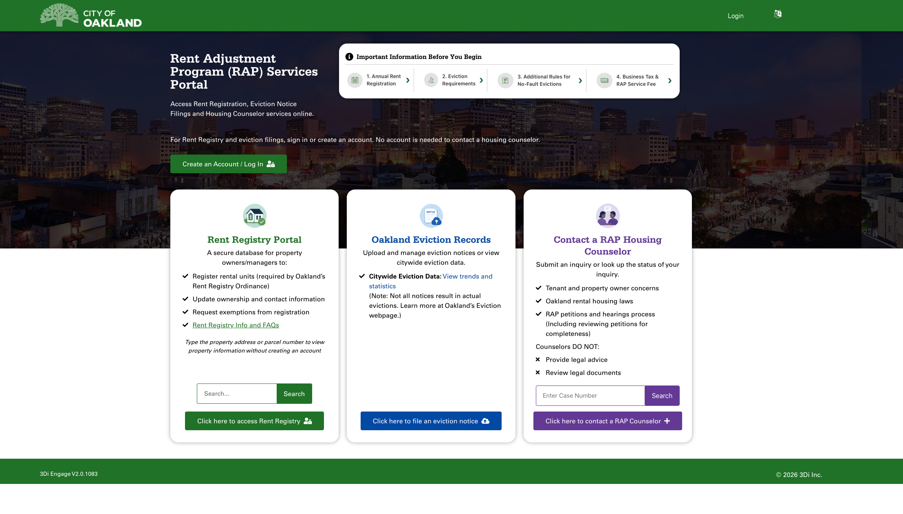

How do I Create an Account with the City of Oakland Rent Registry System?
This section will describe how to create an online account where you can add and manage your Property(s) through the Rent Registry Program.

- Click on the “Create an Account / Log In” button as highlighted in the image below to initiate account creation.

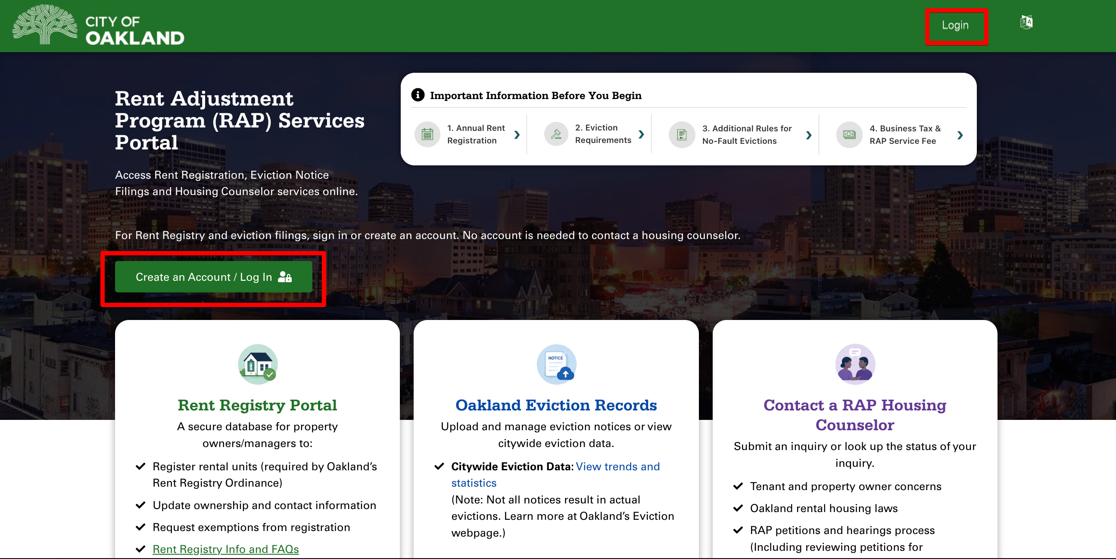

Click on the Register button to open the account creation form.

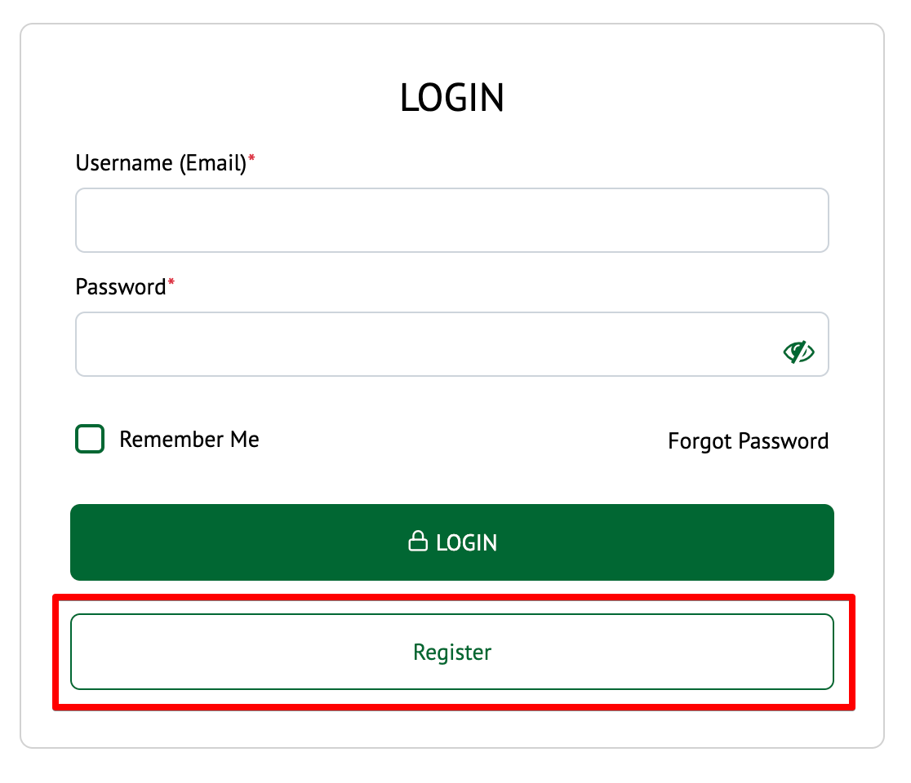

- To create an account, you will need to provide the following:

  - Username (Email)
  - Password (Password should be a minimum of 6 characters, and include at least one
uppercase letter, one lowercase letter, and one symbol (!@#$%^&))
  - Confirm Password
  - First Name
  - Last Name

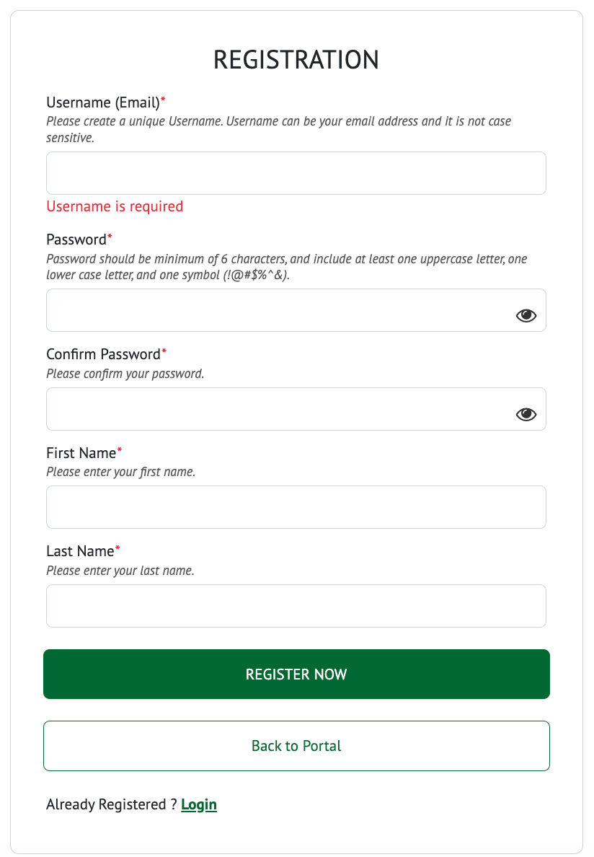

- Enter all the required fields. Once all the required fields are entered, click on the “Register Now” button.

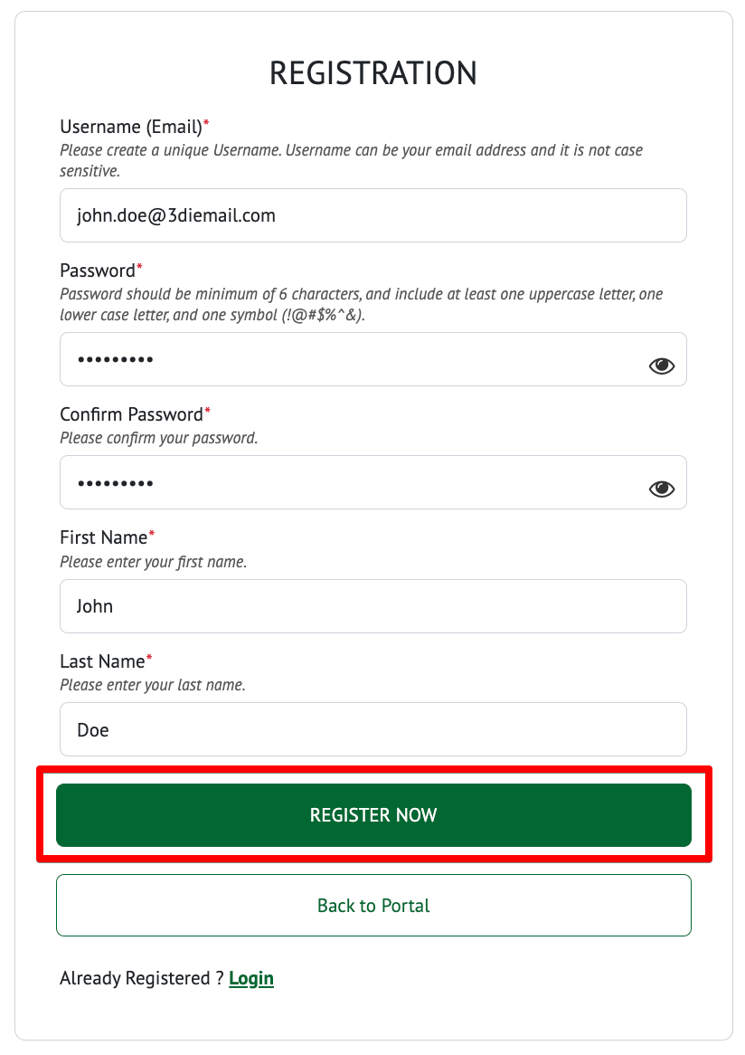

- If there is any required information missing, an error message will appear on the screen to describe the error.

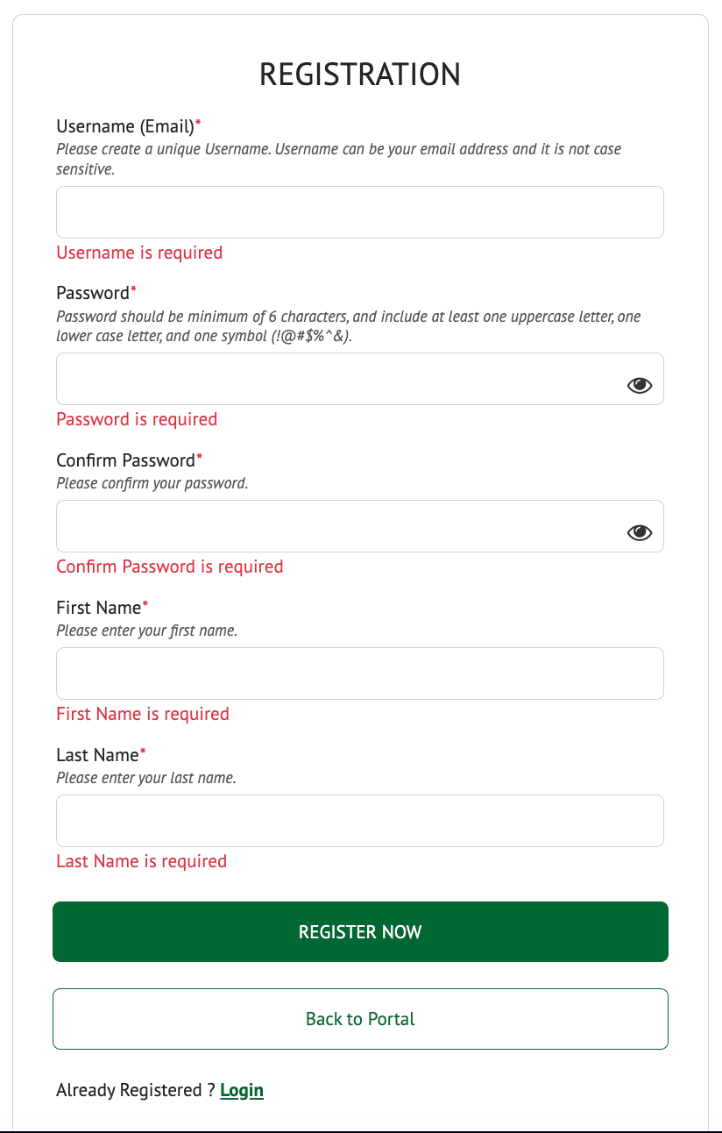

- Once you have successfully registered an account, you will see a pop-up on the screen along with a
message indicating the next steps to complete your account setup. If you don’t see the email, please check
your spam or junk folder. Navigate to your email to verify your account.

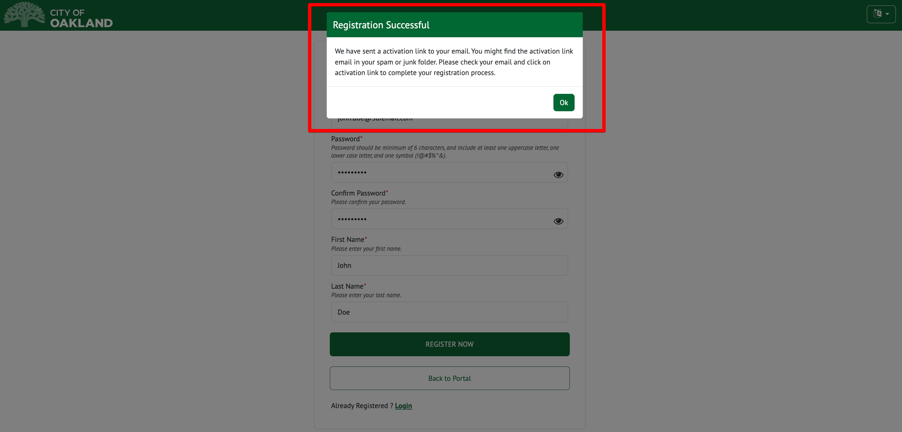

- Click on the verification link in the email from rapregistration@oaklandca.gov

If you did not receive a verification email, check your SPAM folder. If it still did not arrive after 30 minutes, please contact the City of Oakland’s Rent Registry Department and inform them that the Account Activation Email did not arrive.

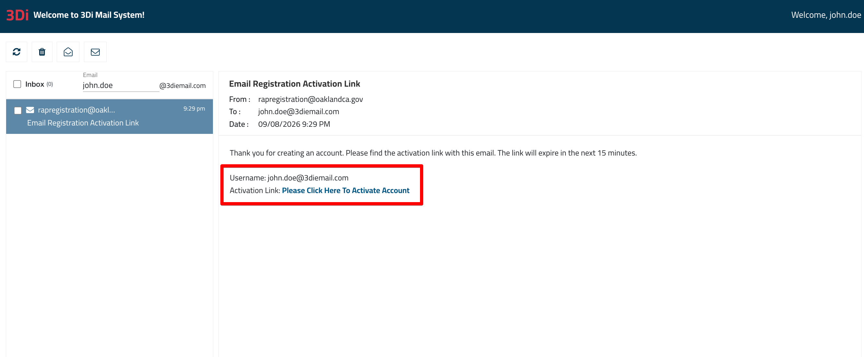

- If the account verification is successful, you will be redirected to a page that indicates “Your account has been successfully created. Please click “Login” to return to the portal and sign in.

If there is an error in the verification process, please contact the City of Oakland’s Rent Registry Department and inform them that the Account Activation failed and you need assistance.
If an account with the same Email ID already exists, an error message will be displayed on the screen. If this is the case, follow the instructions in the next section of this guide to learn how to recover and reset your password using the ‘Forgot Password’ function.

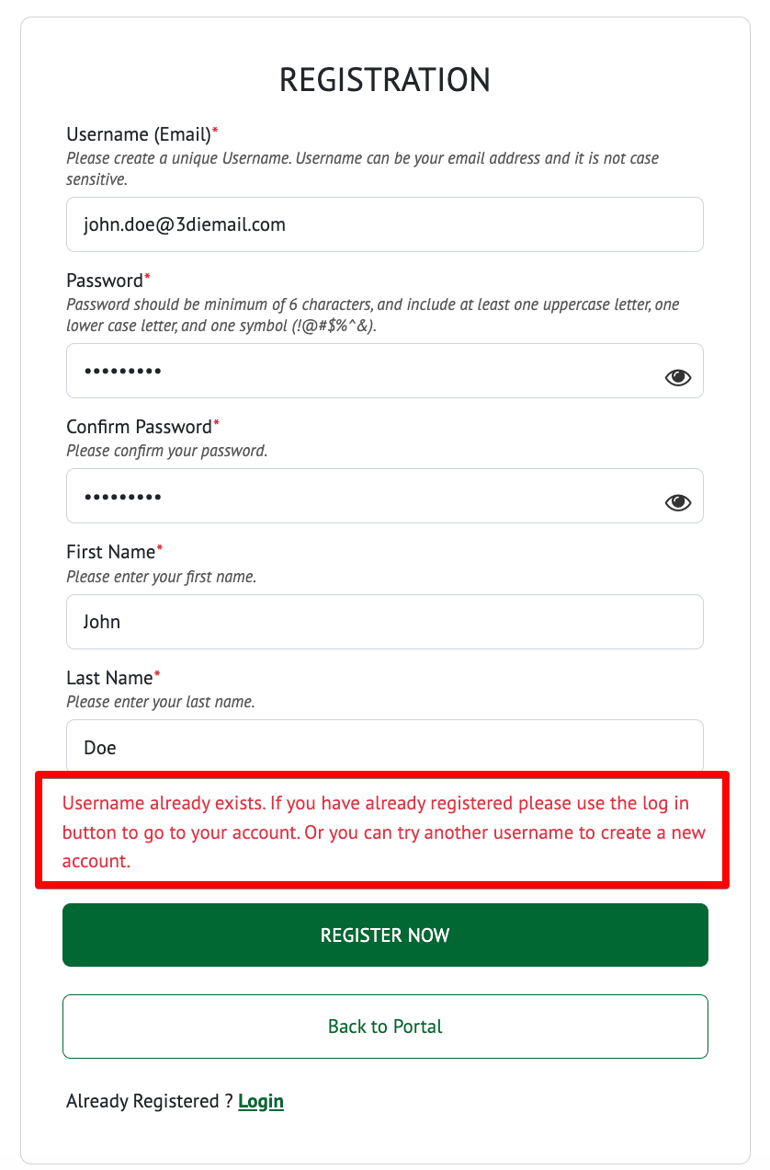

How do I Recover My Password if I Forget It?

This section describes how to recover or reset your password if you have forgotten it.

- Click on the ‘Login’ button to navigate to the Login screen. Next, click on the “Forgot Password” link to initiate the process to recover and reset your password. A pop-up will appear on the screen.

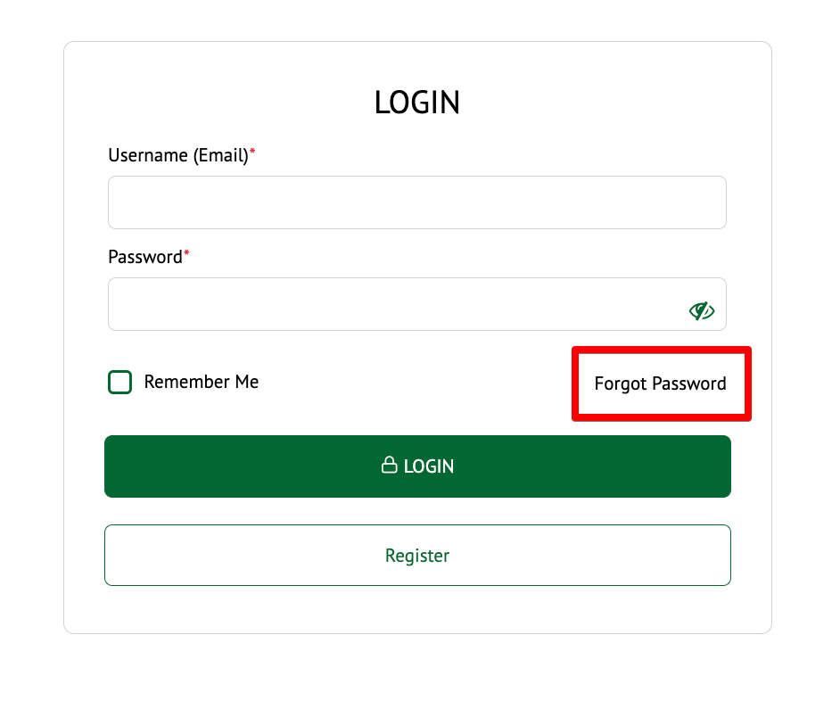

- Enter the Email Address that was used when you created your account.

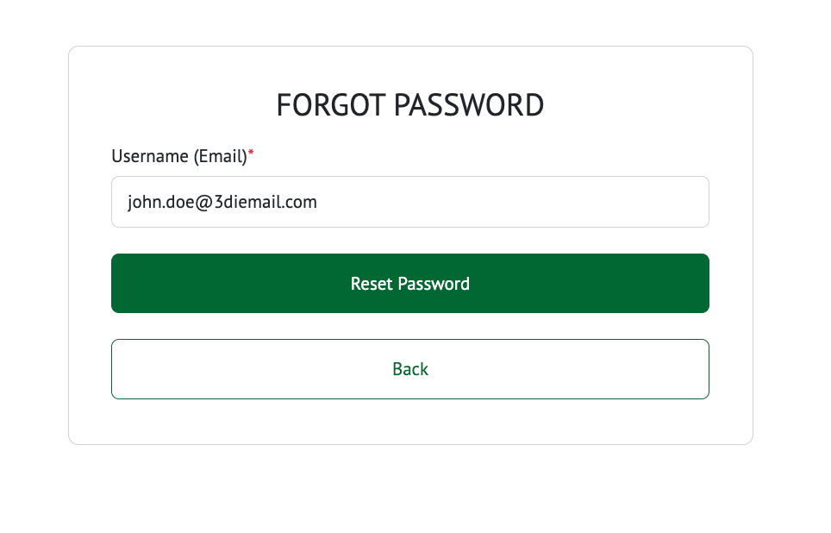

- Once the Email Address is entered, click on the “Reset Password” button.

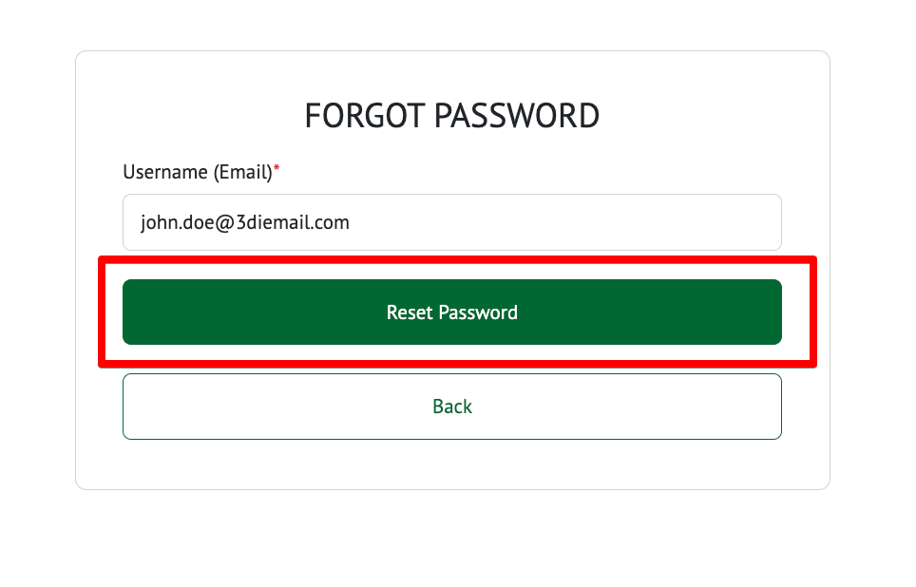

- If there isn’t an account associated with the Email Address, an error will be displayed on the screen indicating the username does not exist.

- If there is an account associated with the entered Email Address, the following pop-up will appear with instructions on how to proceed.

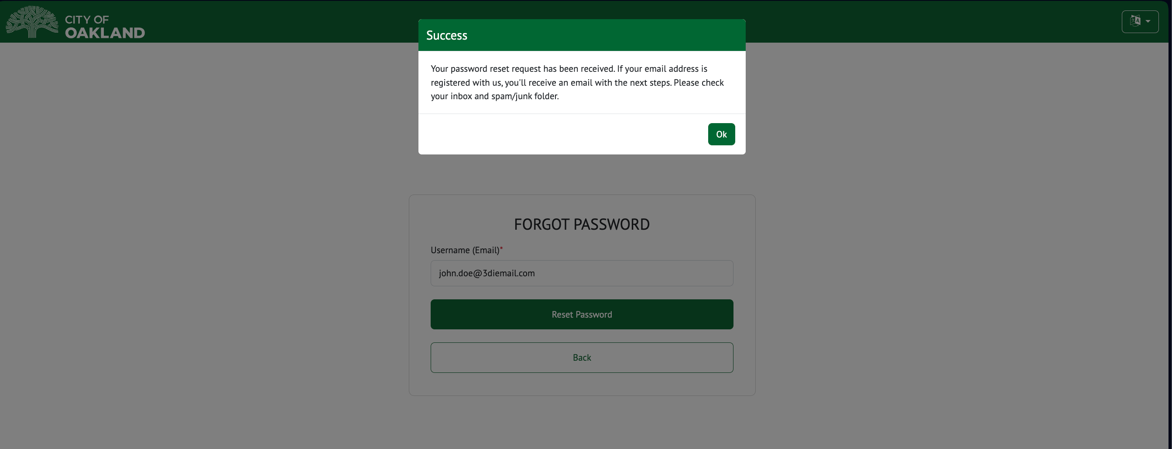

- Check your inbox for the “Temporary Password” message you received. If you did not receive a Temporary Password email, check your SPAM folder. If it still did not arrive after 30 minutes, please contact the City of Oakland’s Rent Registry Department and inform them that the Reset Password Email did not arrive.
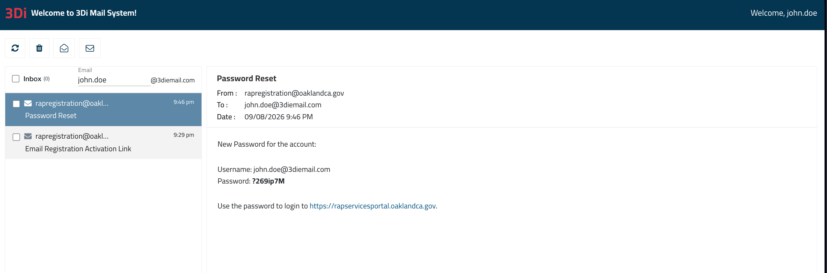

- Enter the credentials and click on “Login”.
- You will be asked to change the temporary password after the initial login. Change the temporary password and login to the portal.

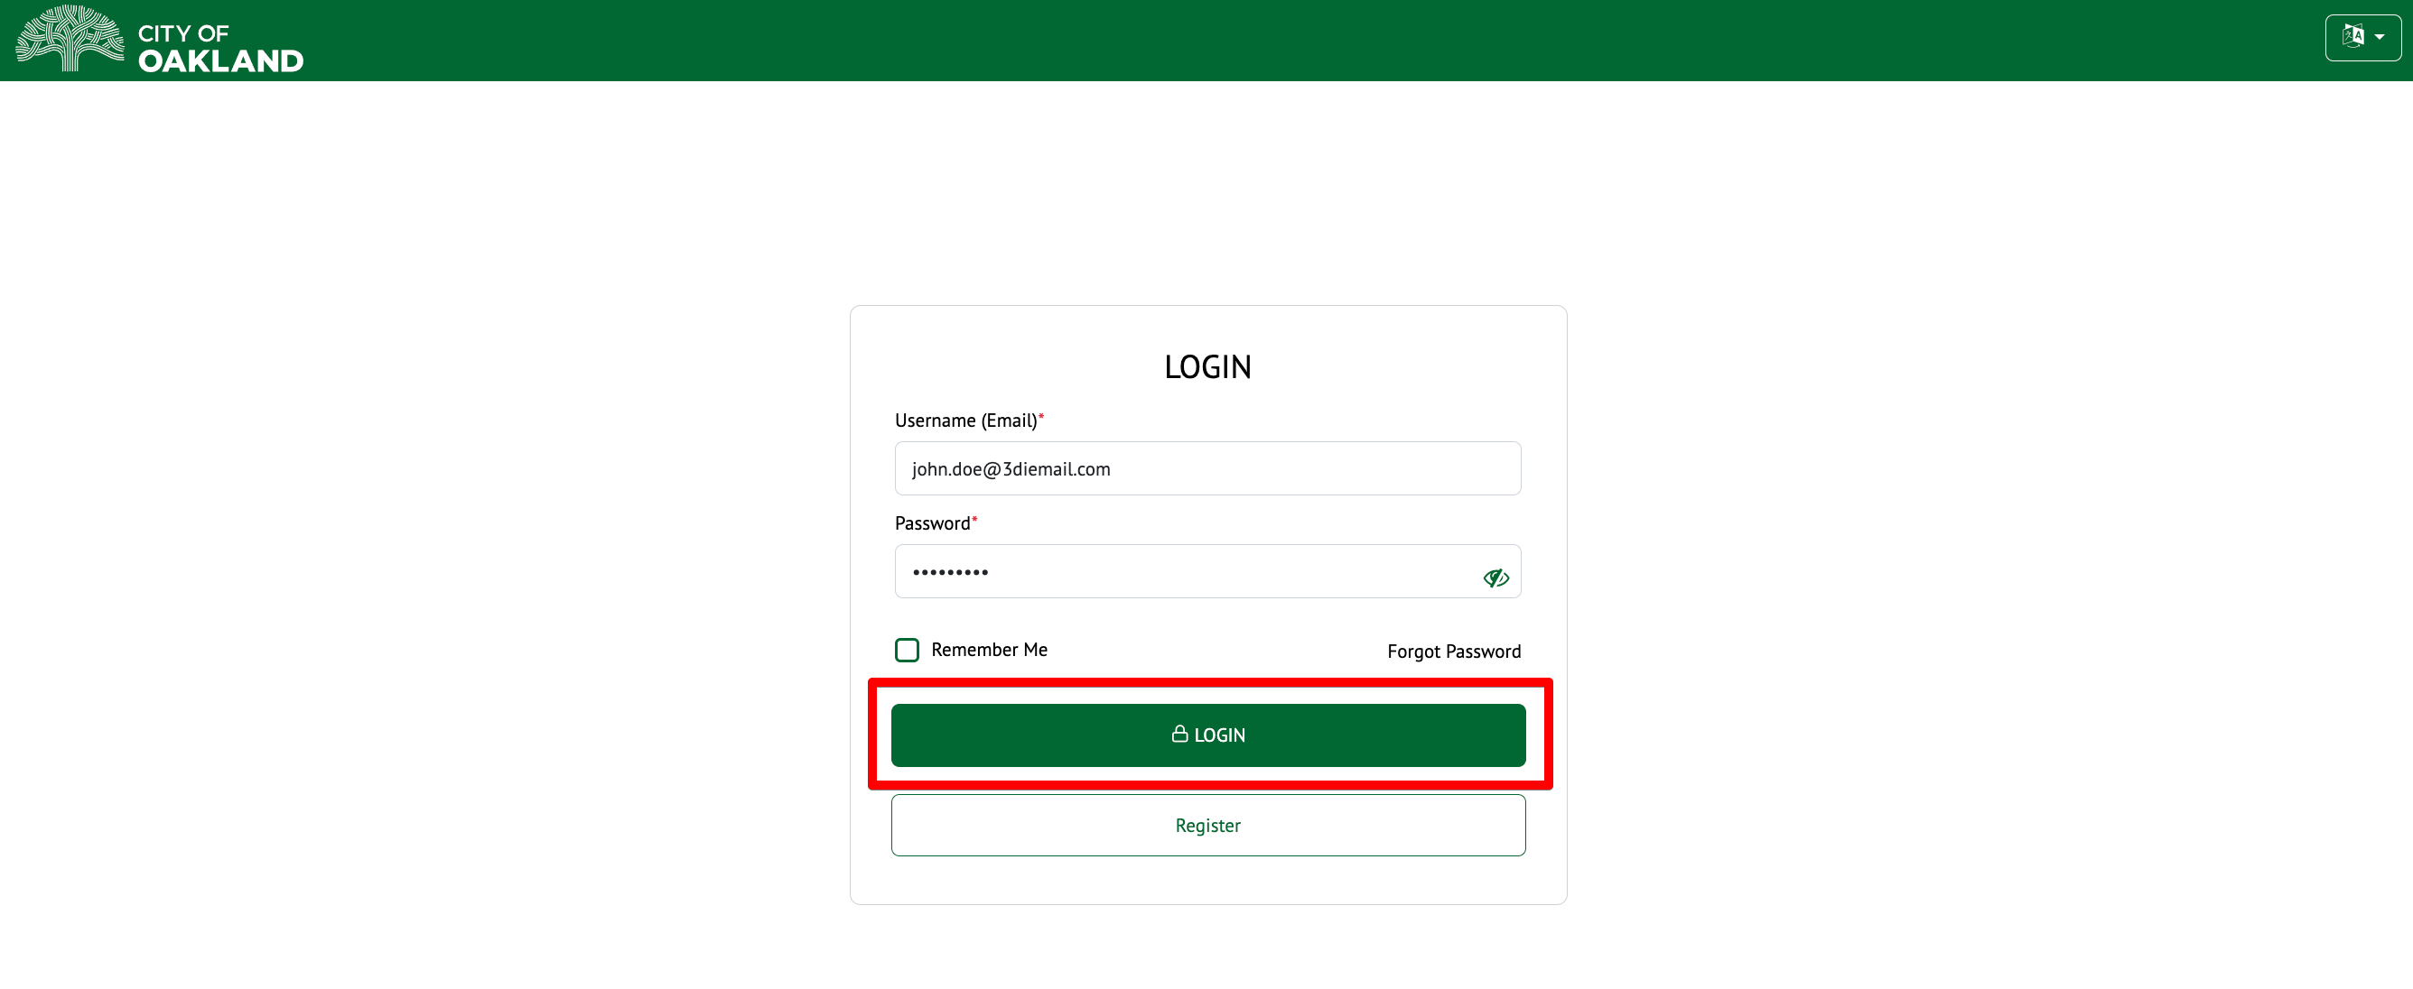

It will redirect the user to the Owner dashboard which will show the 3 cards – Eviction, Rent Registry and Client Management.

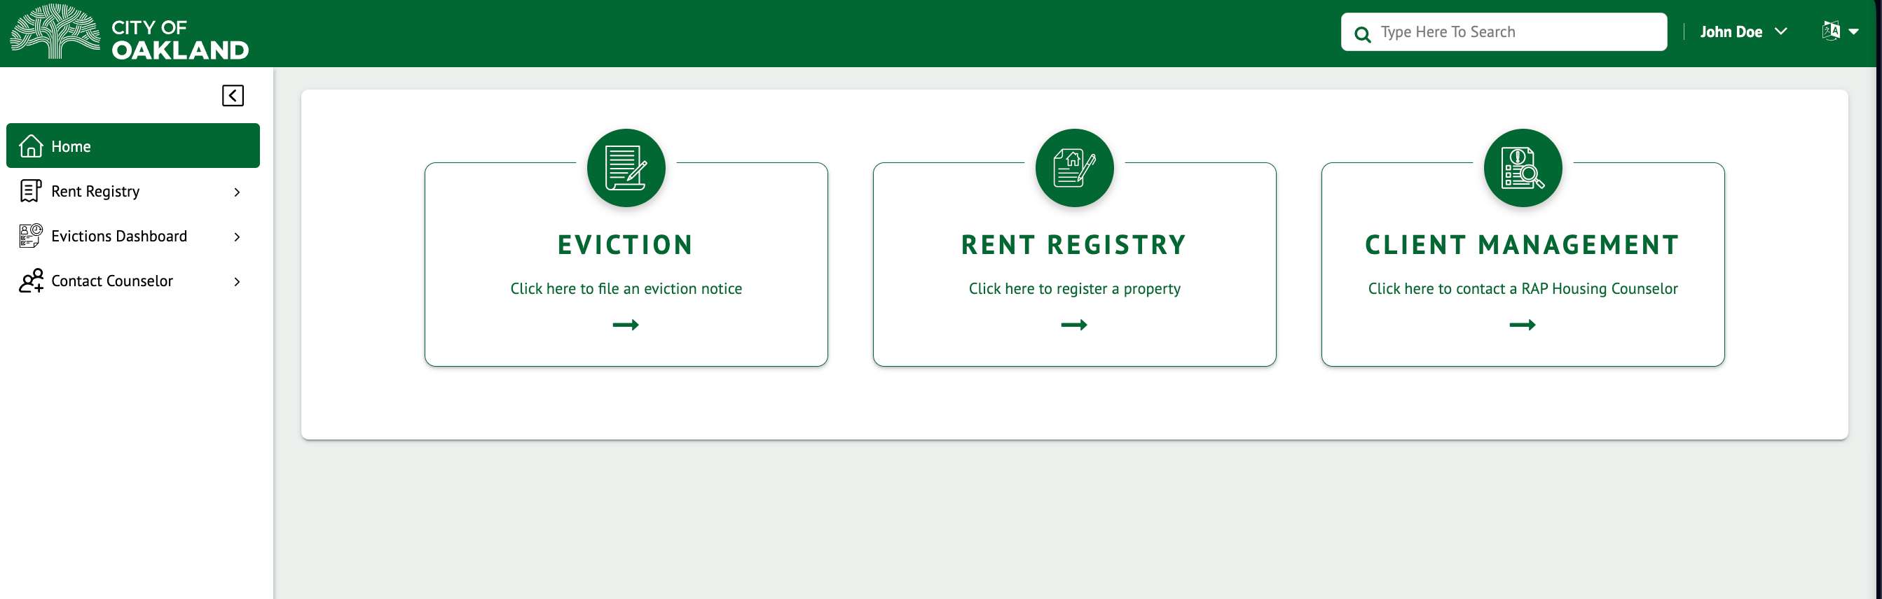

Click on the Rent Registry card to proceed to the Rent Registry Portal.

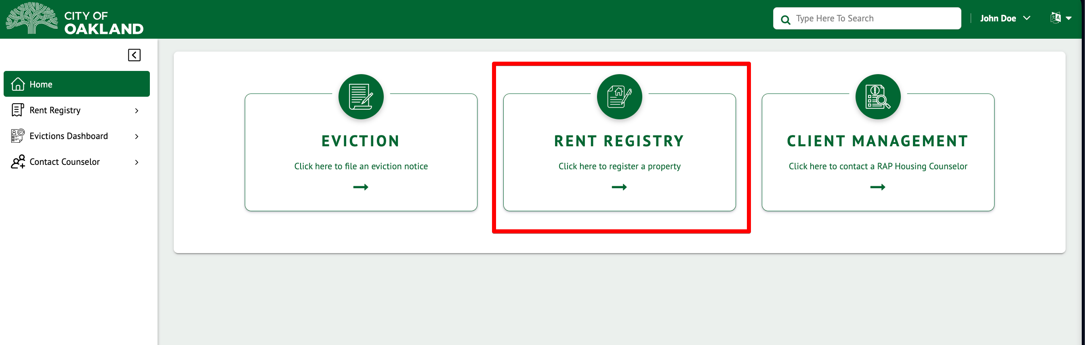

If you have previously logged in and added Properties to your profile, your “My Properties” will list all your current Property(s).

- Current Properties - The “Current Properties” tab contains all the Property(s) that you have manually added to your profile and that you are actively responsible for registering. When you log in, this tab will be displayed by default. This tab is where you will need to go if you need to add a Property to your profile.

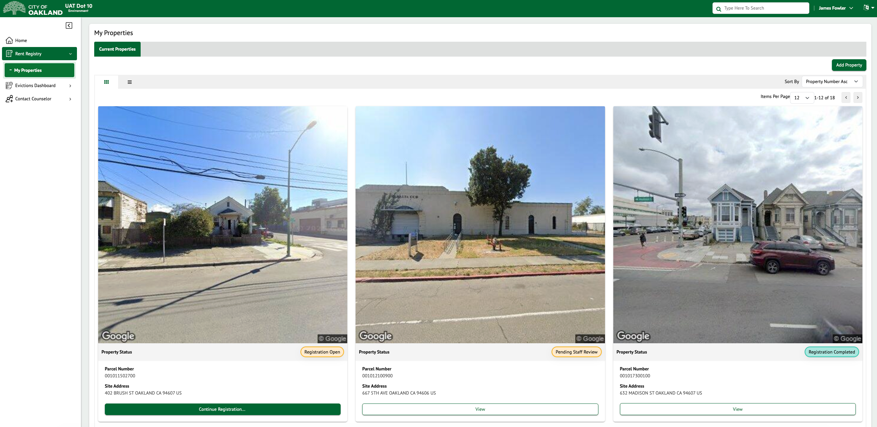

How Do I Return to My Dashboard/Property Listings?

If you have navigated away from your dashboard by conducting a search or viewing a Property’s Details page, you can return to the Dashboard in one of two ways:
- Click on the Logo in the top left corner.
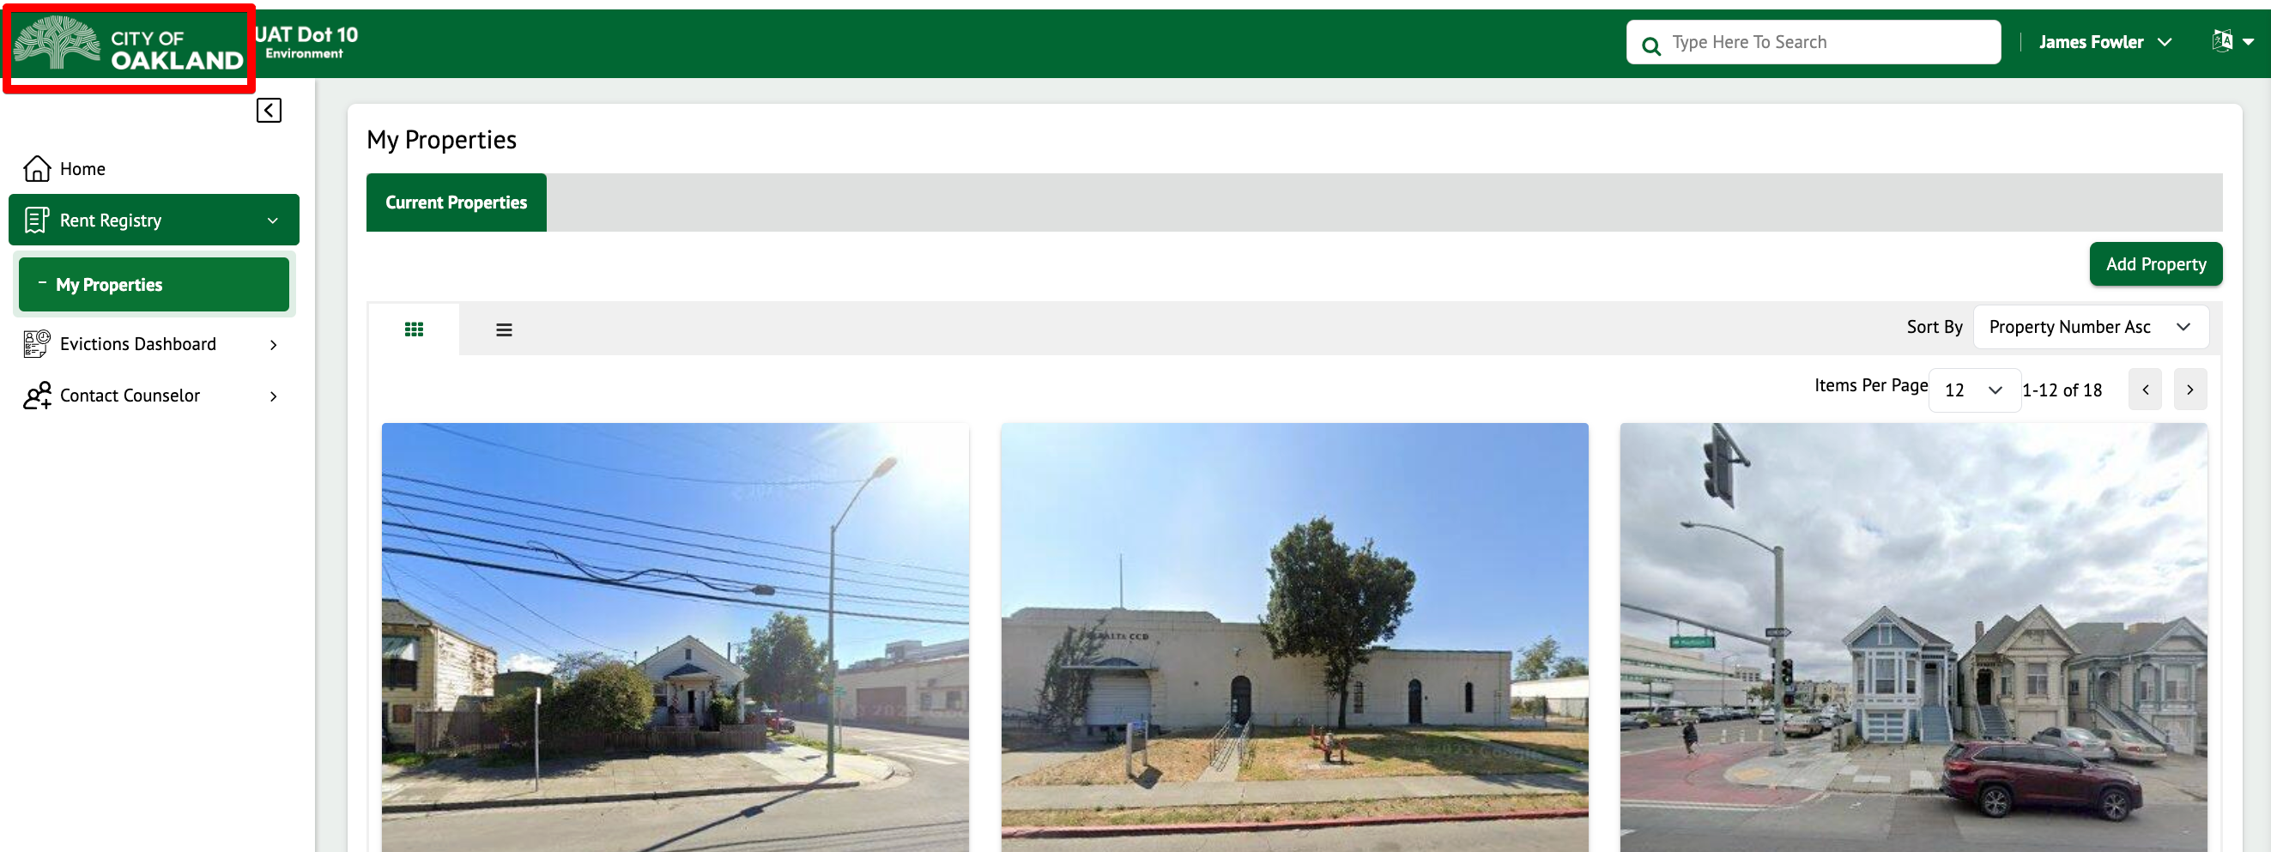

- Click on the “My Properties” option in the left menu.

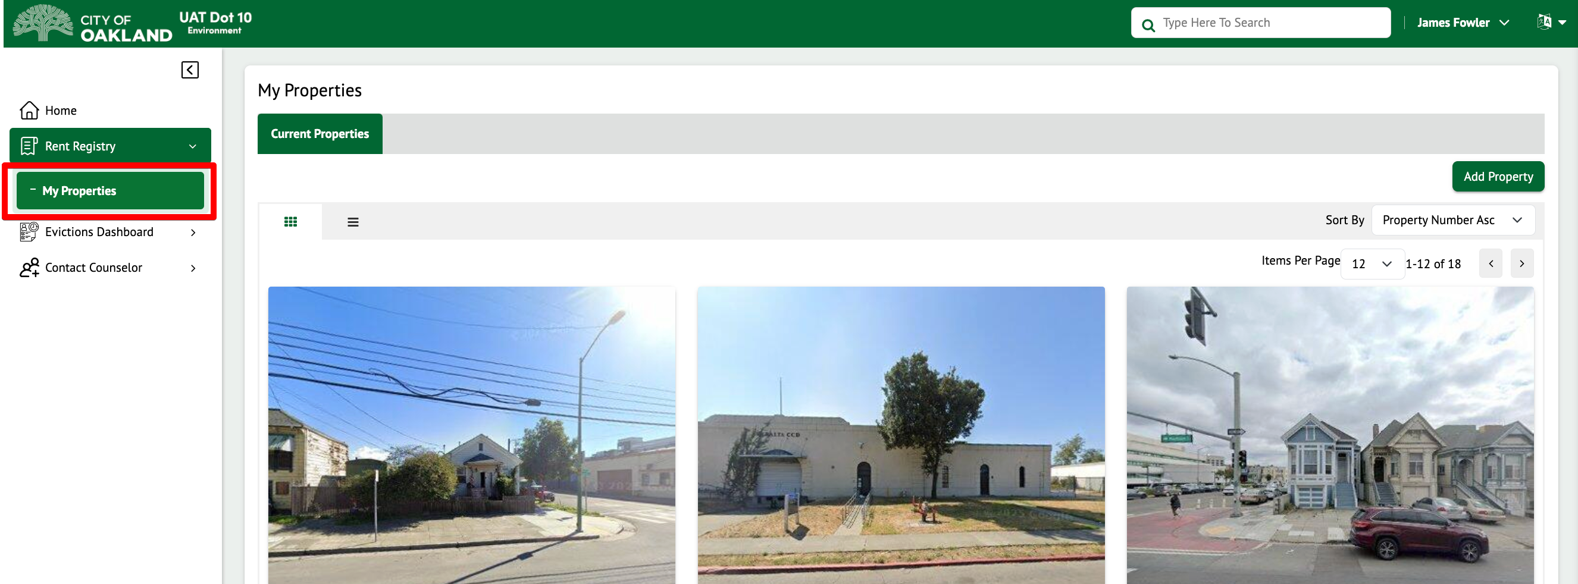

How to Search for a Property
To search for a property, enter the search criteria (Address or APN) in the search box at the top. The matching categories will be displayed. Click to view the respective category in the results.

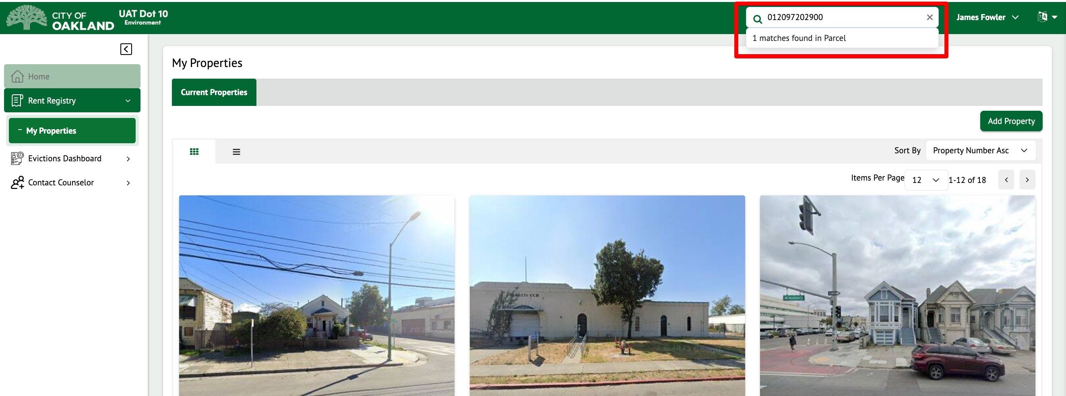

The results will be displayed, and you can click on a property to view it.

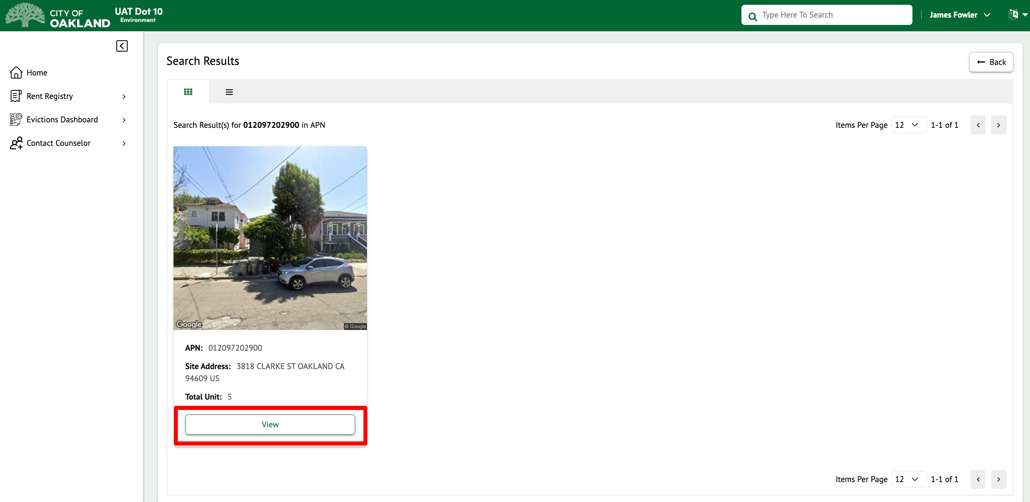

How do I Add a Property to My Dashboard?

This section will describe how you can add a Property to your Dashboard for Registration. This is a one-time activity for each Property that you own. Once the Property is added, it will remain on your profile until there is a change in ownership of the Property.
The City of Oakland’s Rent Registry Department will provide you with your Property Number and PIN. The PIN is required to add the property to your profile so we can ensure the intended user is adding the correct Property to manage. Each Property will have its own unique PIN.
If you do not know your Property’s PIN, call the City of Oakland’s Rent Registry Department at (510) 238-3721
and inform them that you need your Property’s PIN. They may ask some questions to confirm your identity.
Follow the steps below to learn how to add a Property to your dashboard.
- From the “Current Properties” tab, click on the Add Property button.
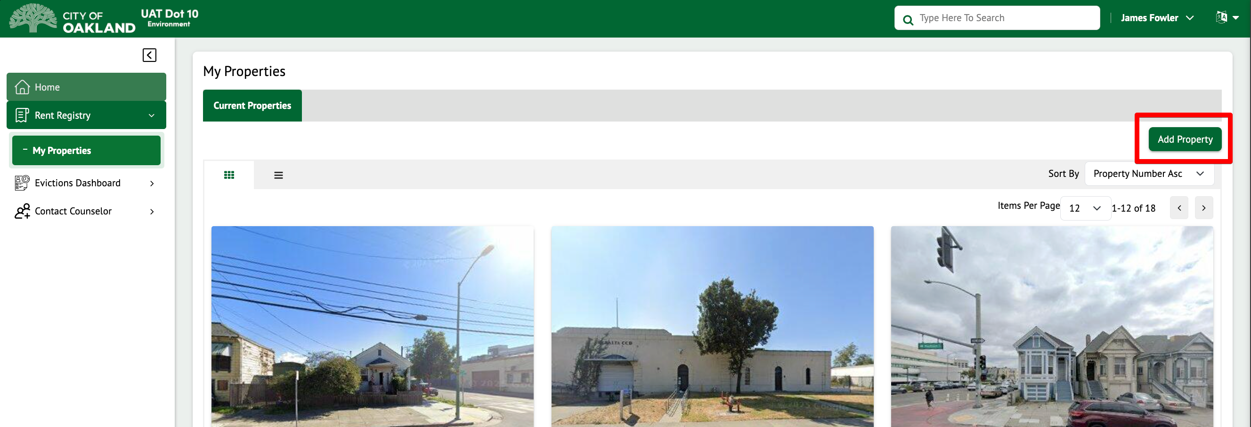

- The Add Property stepper form will appear.
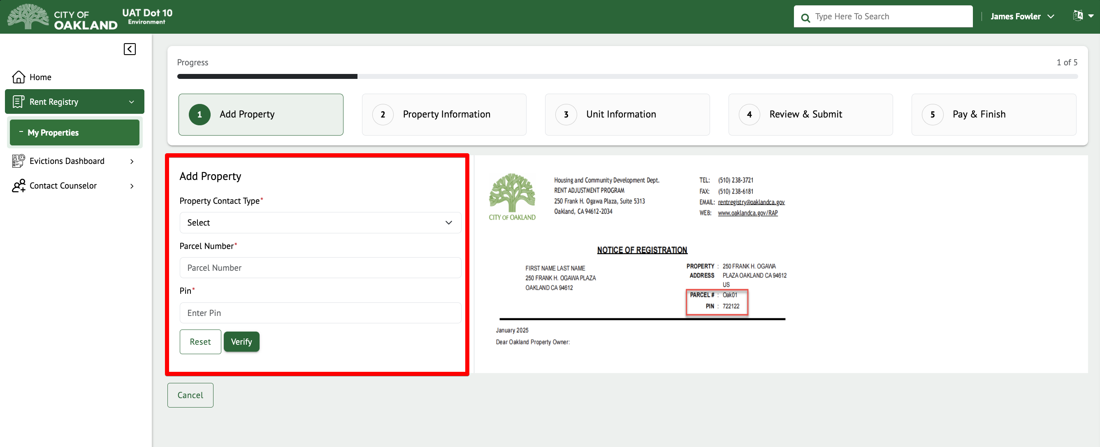

- Select Property Contact Type and enter the Parcel Number (APN) and PIN for your property. The PIN can be found in the Registration Packet that was mailed to you.

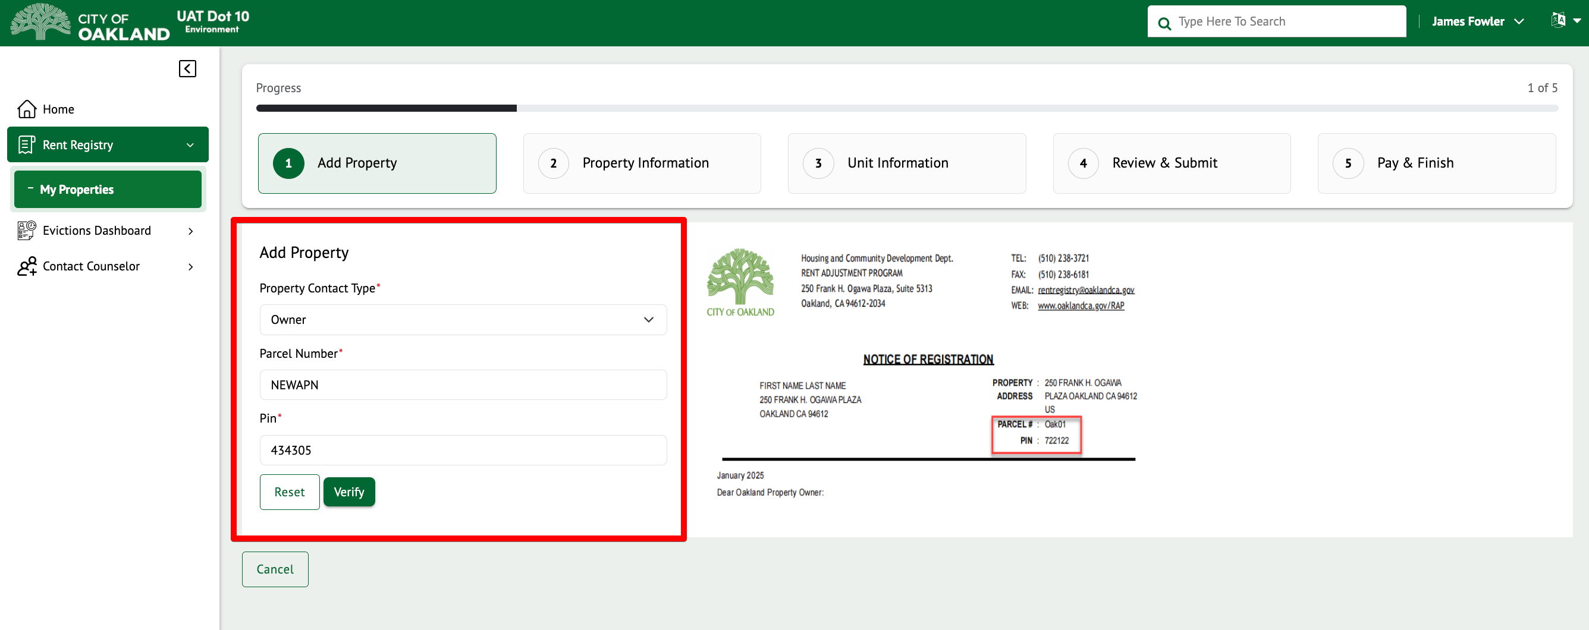

- Once the Property Number and PIN are entered, click on the “Verify” button.

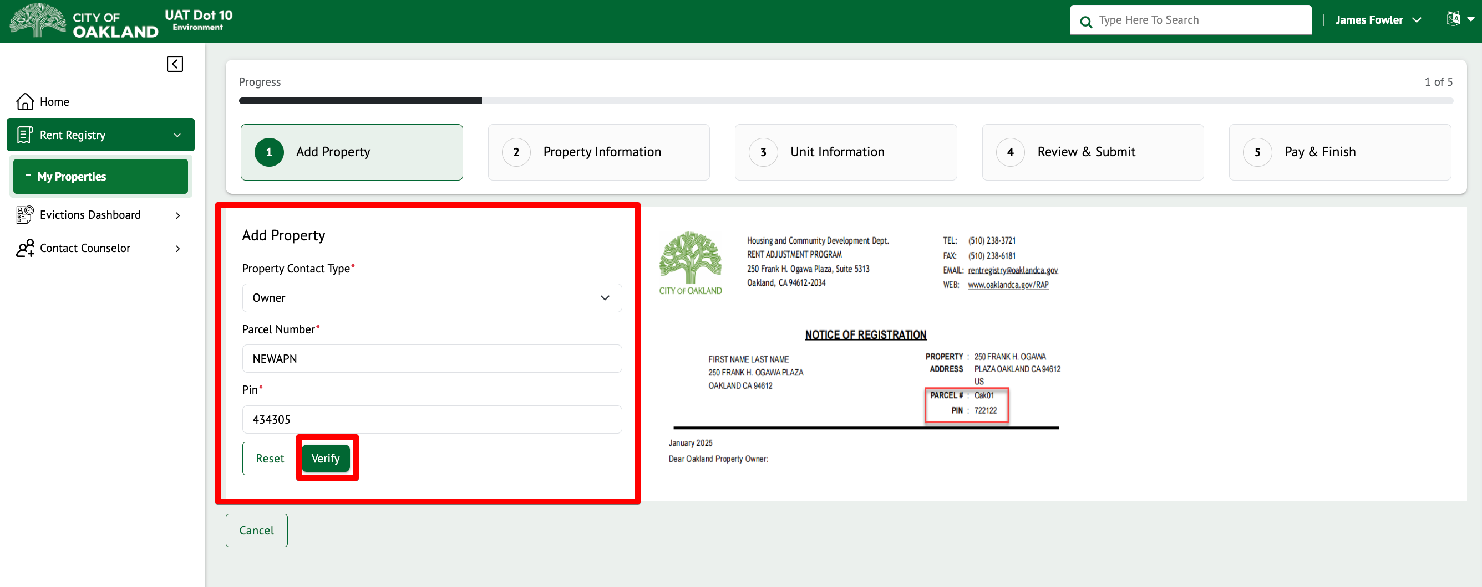

If there is an error with the Property Number and PIN combination, an error message will be displayed on the screen and will describe the error. If you see an error message, try entering the Property Number and PIN again. If the issue persists, contact the City of Oakland’s Rent Registry Department and inform them of your issue.
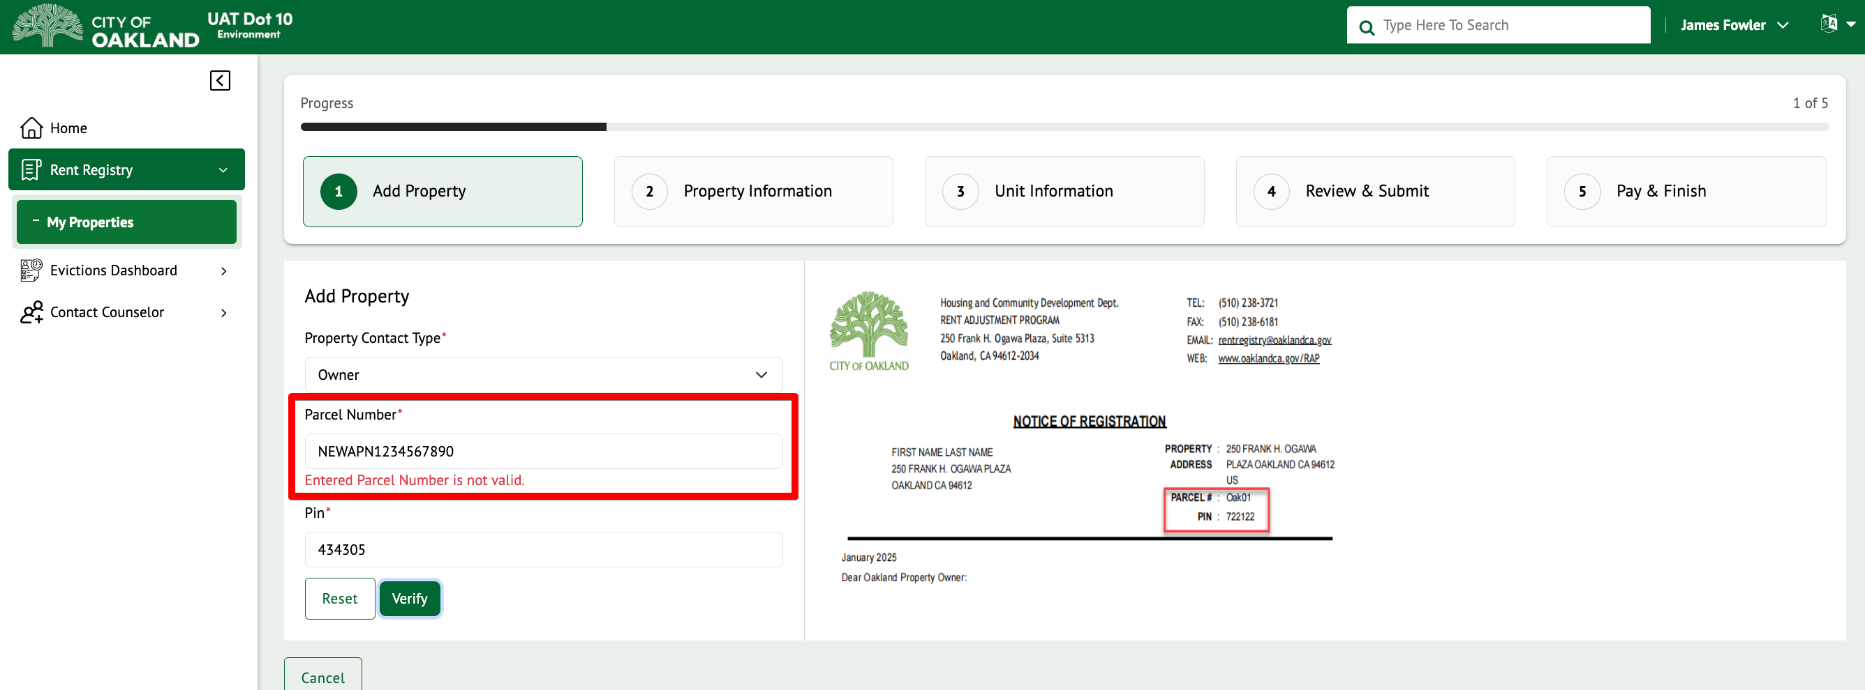

If you have successfully entered the correct Property Number and PIN combination, the associated Site Address for the Property will appear as shown below.

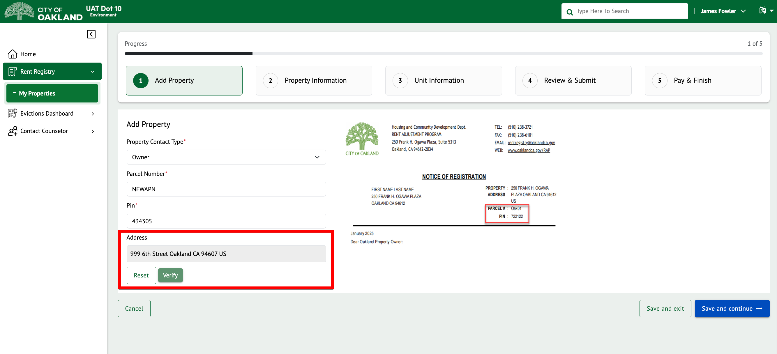

Once the Property has been verified, you can select to continue with registration by clicking on “Save and continue”, or you can return at another time and click on “Save and exit” to exit the process and return to the current property listings.

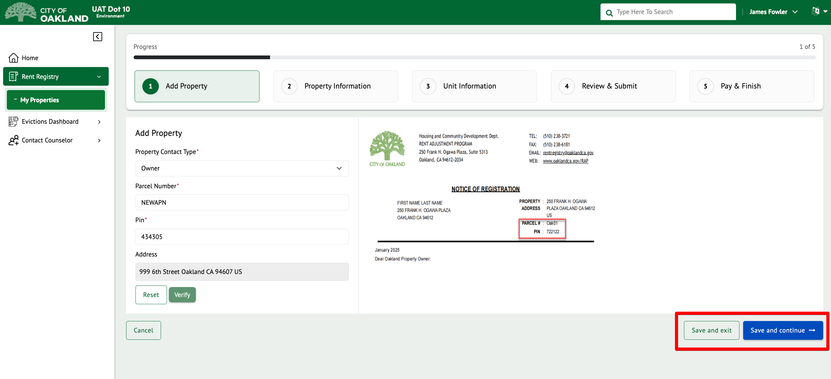

How do I Register my Property?

The main purpose of the City of Oakland Online Rent Registry System is for Landlords to Register their Properties and Units with the City of Oakland and to keep the City informed, throughout the year, of the changes in Unit Rent, Occupancy, and Property Contact Information. In this section, we will describe how to properly register a Property with the City.
This guide will describe how to Register from start to finish, breaking down the features and functions that are available through each step.
The registration process has been modified to break things down, step by step. Below is an outline of the steps and how to initiate the registration process, whether it is your first time or not.
- Step 1 – Add Property – Property Contact Type, Property, PIN
- Step 2 – Property Information – Address, Owner contact details, Property Manager contact details
- Step 3 – Unit Information – Depending on the Occupant type, additional details may be required.
- Step 4 – Review & Submit
- Step 5 – Pay & Finish

On the “My Properties” Page, you will see a “Continue Registration” button for any property where registration has not yet been submitted (or needs to be resubmitted). Click on the green button to follow the steps of registration.

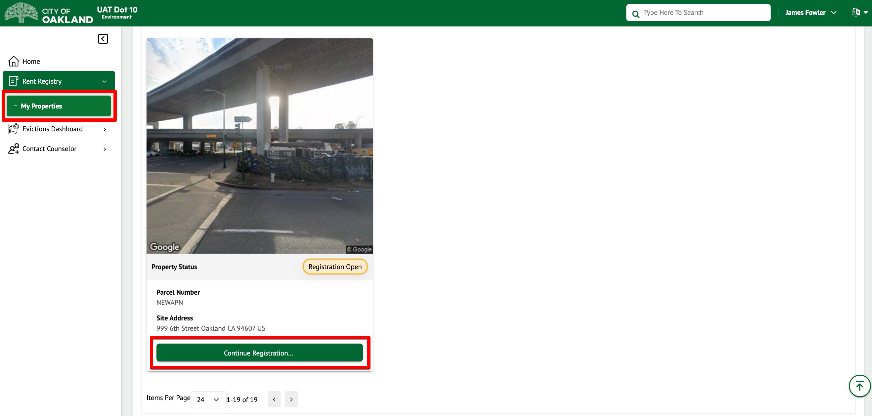

Step 2 - Property Information

The “Property Information” section will be displayed once the registration process begins, providing the required steps and general instructions to follow.

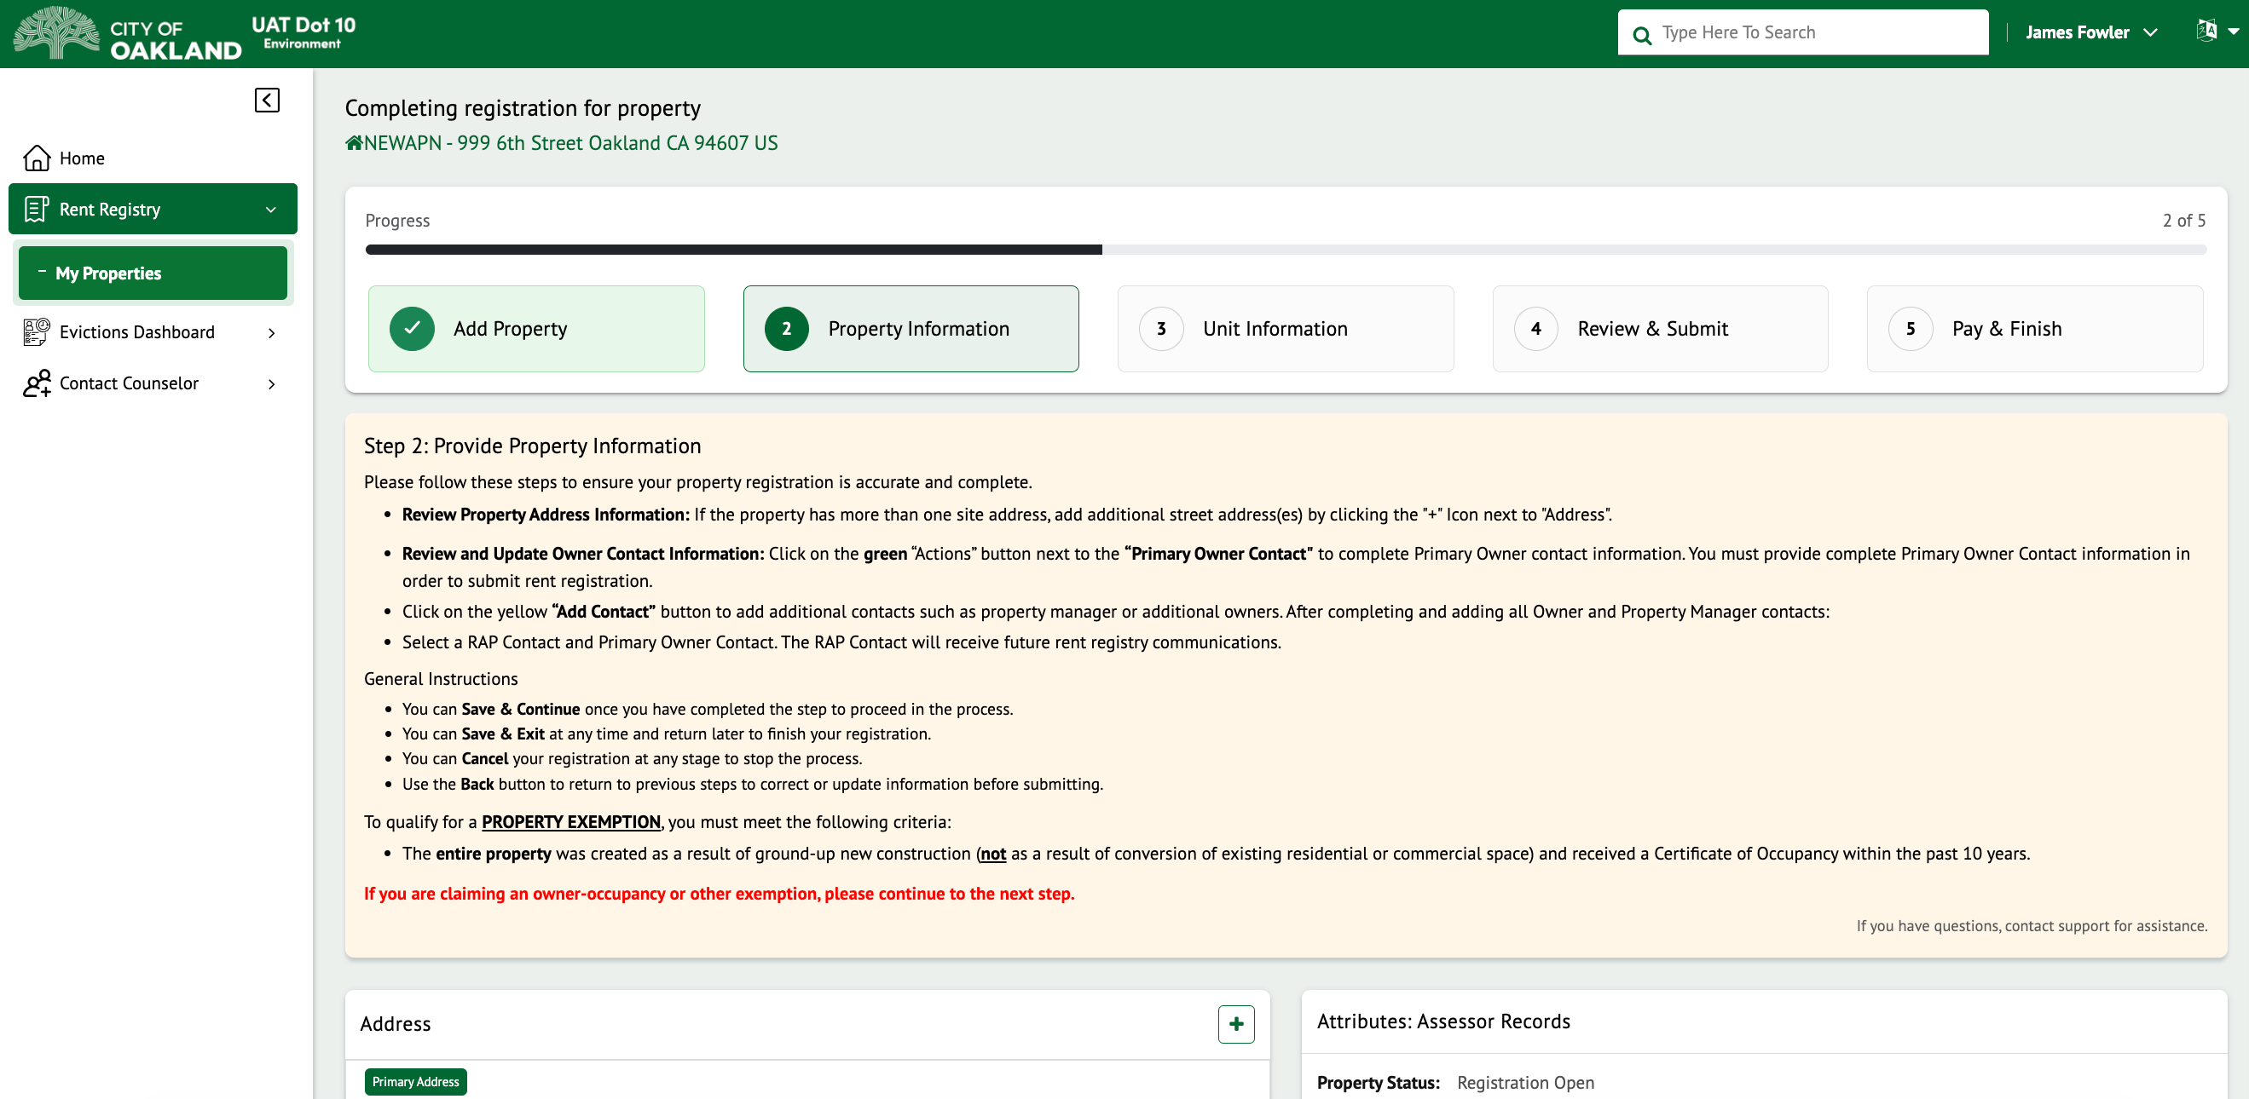

Addresses

To add a new address (to be used as part of the unit’s mailing address while adding units), click on the Add (+) icon as shown below. A pop-up will appear where you can enter the address details and save.

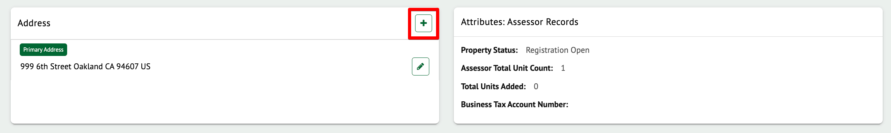

To edit an existing address, click the edit icon as shown below. A pop-up will appear where you can enter the address details and save.
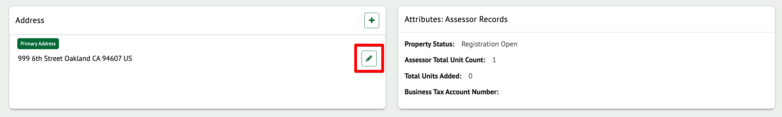

Contacts

The contacts section will list any/all contacts associated with the property, including the person who has claimed the property for registration. You can add new contacts and/or edit existing contact information as needed.

Please note: if the property is under new ownership, please submit an Ownership Amendment.

In the Contacts section, the following Contact Types can be added:
- Owner Contact Information
- Property Manager Contact Information
Owner contact information must be added to the Property in order to be eligible to submit any Exemptions, Amendments, and even Registration.
To edit an existing contact, click on the “Actions” button and select ‘Edit’ as shown below. A pop-up will appear for you to edit the contact details. Any field that contains a red asterisk (*) means the information is required. Ensure all the required information is present and click on Save.
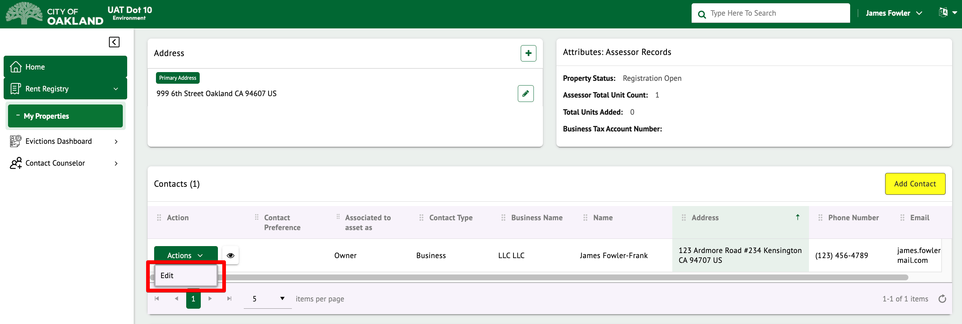

To add a new contact, click on the yellow “Add Contact” button as shown below.

The Add Contact Details pop-up will appear, as shown below, where you will be able to select from the available contact types.

Depending on the contact type selection, additional fields may appear. Any field which contains a red asterisk (*) means the information is required. Ensure all the required information is present and click on Save.

The newly added contact will appear in the Contacts grid as shown below.

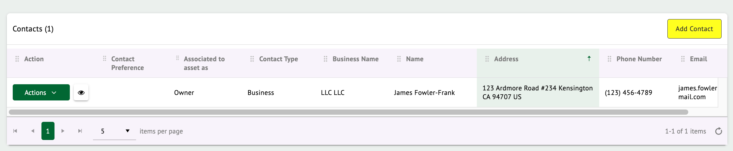

NOTE: The system REQUIRES you to add an Owner Contact.

When adding a Property Manager contact, you can click on the “Same as Primary Owner” checkbox as shown below to prefill the owner contact information. This can be used if you do not have a property manager OR if the owner is also acting as the manager. Once you enter the required contact information, click on Save to add the contact.

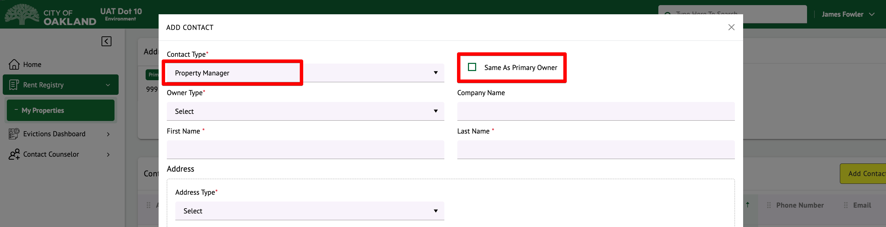

The newly added property Manager details will be updated under contact details.

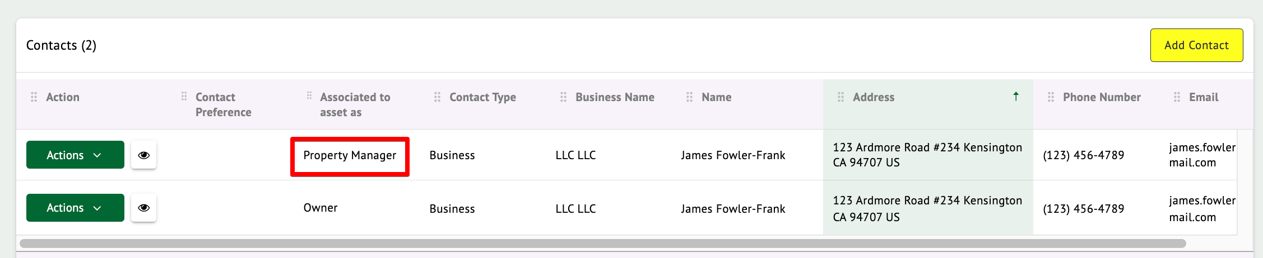

Contact/Communication Preference

Using the dropdown menus, you can select which of the added contacts will be the RAP Contact and which contact is the Primary Owner of the property.

The selected RAP Contact will be the recipient of all RAP rent registry communications. The Primary Owner Contact may be contacted regarding other Rent Adjustment/Just Cause ordinance updates. These selections may be the same.

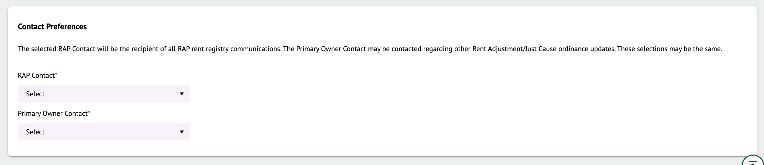

To set the RAP Contact, select the appropriate contact name from the drop-down list as shown below. You will need to do the same for the Primary Owner Contact drop-down as well.

Once a selection is made, it will automatically be saved, and the ‘Contact Preference’ on the contacts grid will be updated as shown below. These selections can be modified at any time.

Property Exemption

Review the City of Oakland’s Rent Registry Department Ordinance to determine if your property qualifies for a complete Property Exemption. If the Property qualifies for a Property Exemption, you are encouraged to submit a Property Exemption. Staff will review each Property Exemption that is submitted and determine if the Exemption should be applied to the property or not. This will be apparent through the Property’s Status.

To apply for a Property Exemption, click on the checkbox for “Do you want to apply for Property Exemption?”.

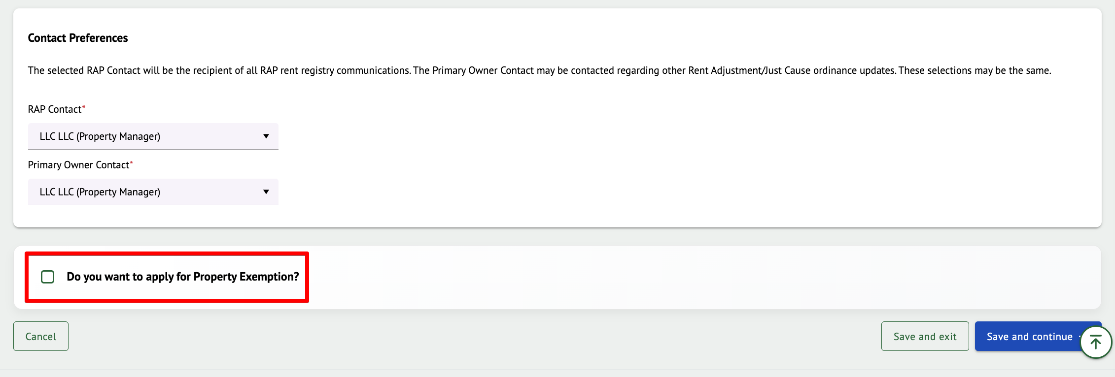

Once clicked, a pop-up will appear for the property exemption submission.

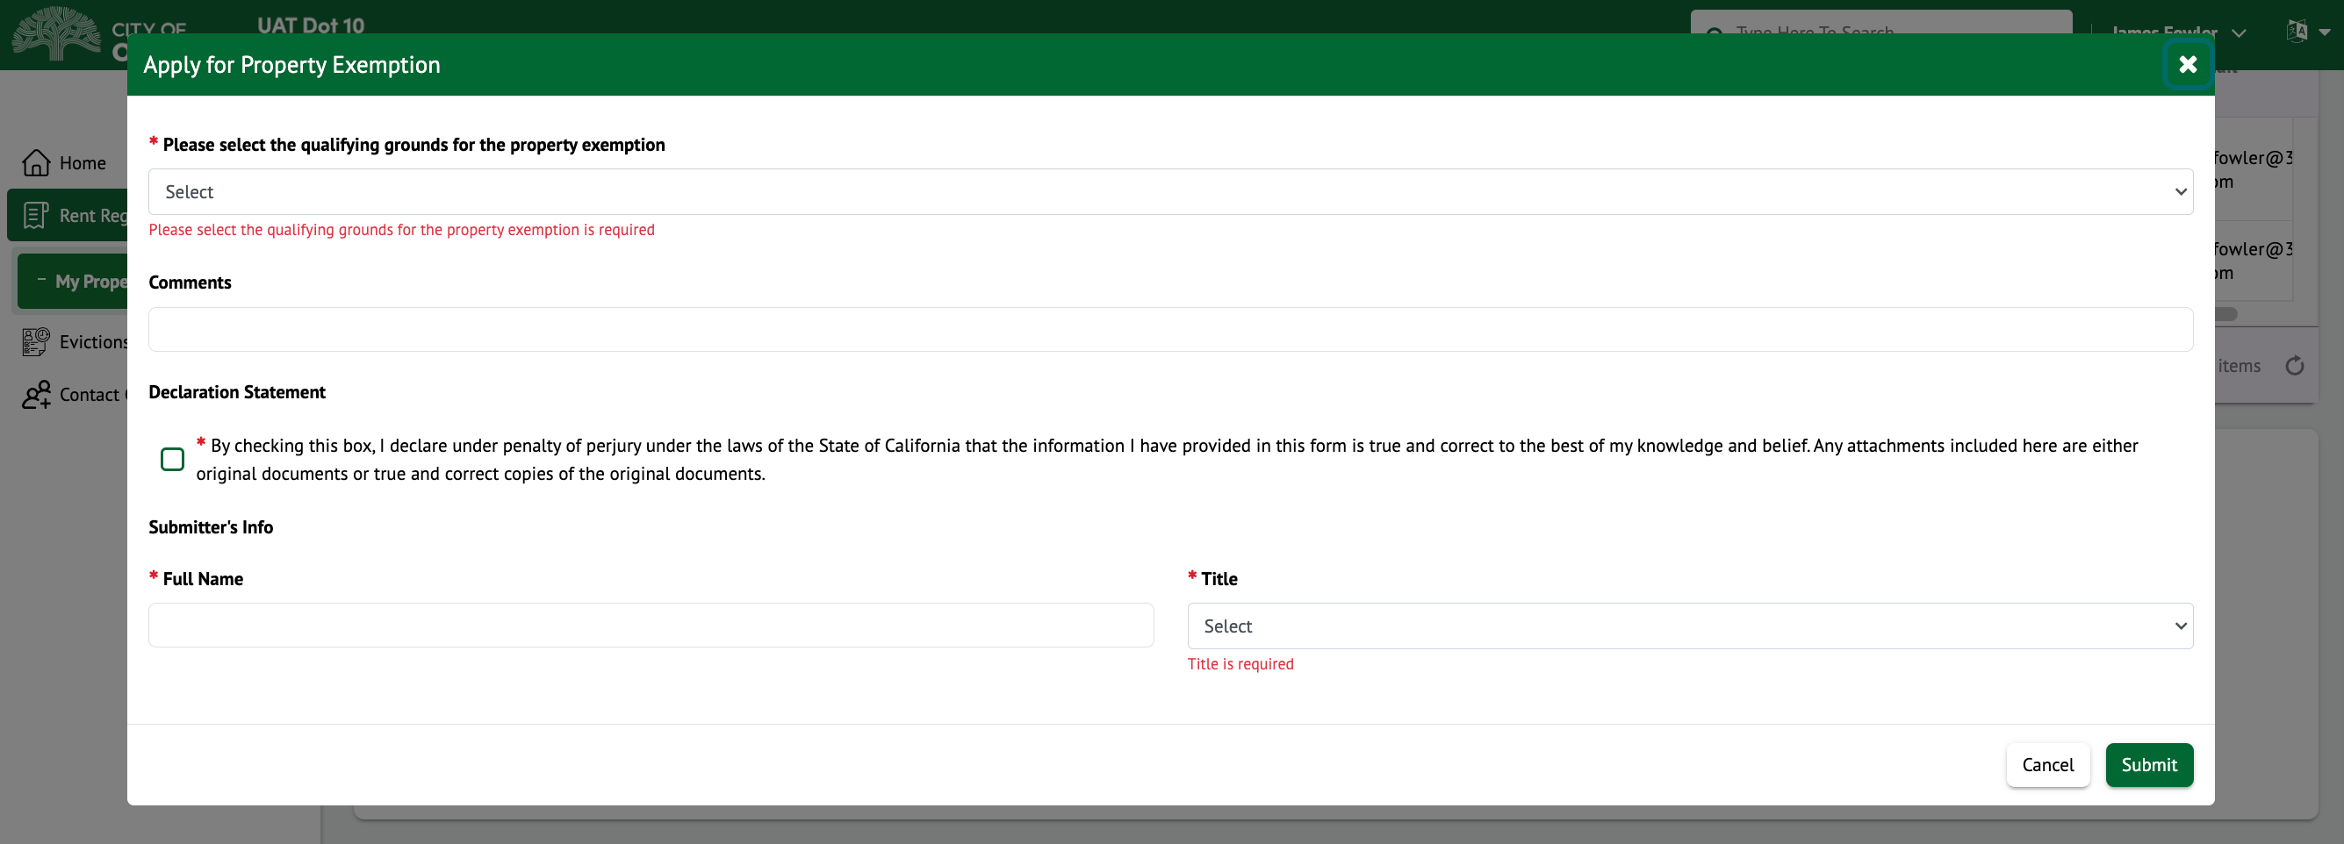

Any field that contains a red asterisk (*) means the information is required. Ensure all the required information is present and click on Submit.
A case number will be generated upon successful submission. You can click on “Ok” to close the pop-up.

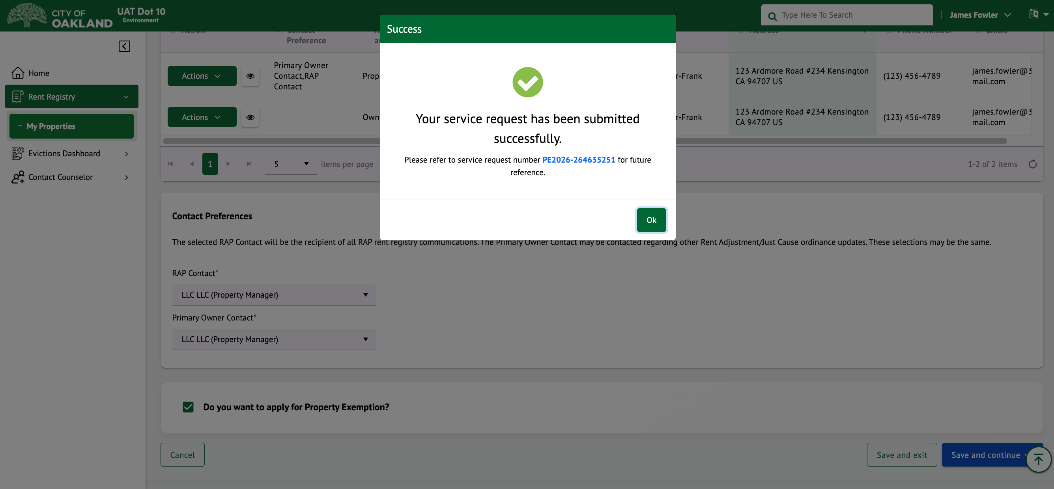

The screen will also show that a Property Exemption was submitted. Staff will need to review and approve or deny the Property Exemption.

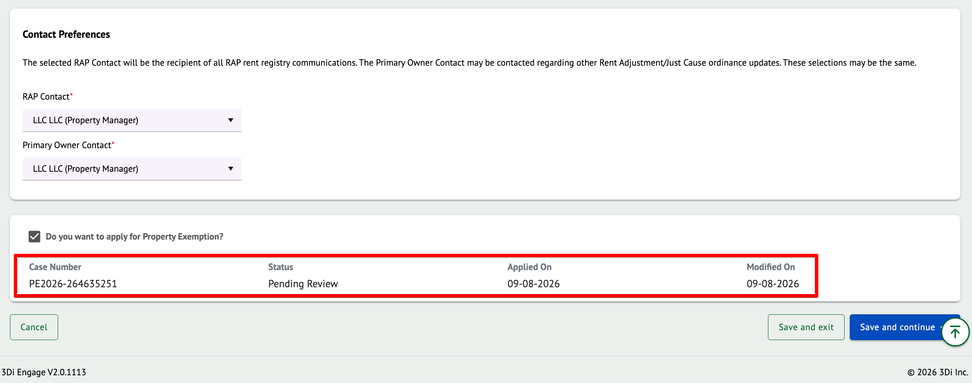

Note: Even if you have submitted a Property Exemption, you still must continue to complete the registration process and submit your property. Click on “Save and continue” to move to Step 3.

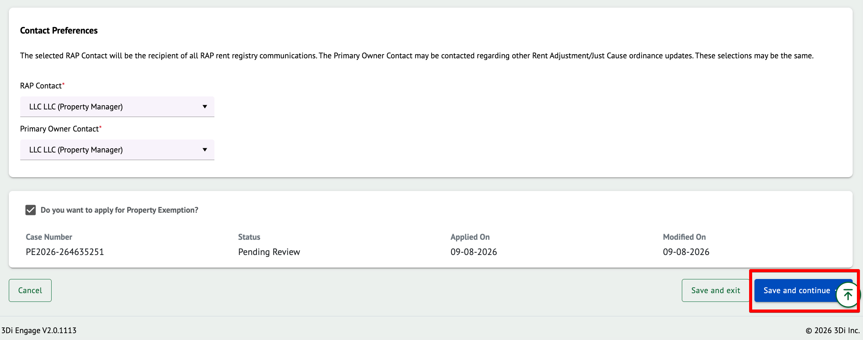

Step 3 - Unit Information

This section will describe how to manage your property’s units. We will describe how to add a new unit, modify an existing unit, and how to update unit information through case submissions.

The purpose of the annual registration is to ensure that the information for every unit is up to date, so modifications will likely be necessary.

Any units that have been added to the property will be displayed in the Unit Information section. In the screenshot below, the property has 0 units added; therefore, it is blank.

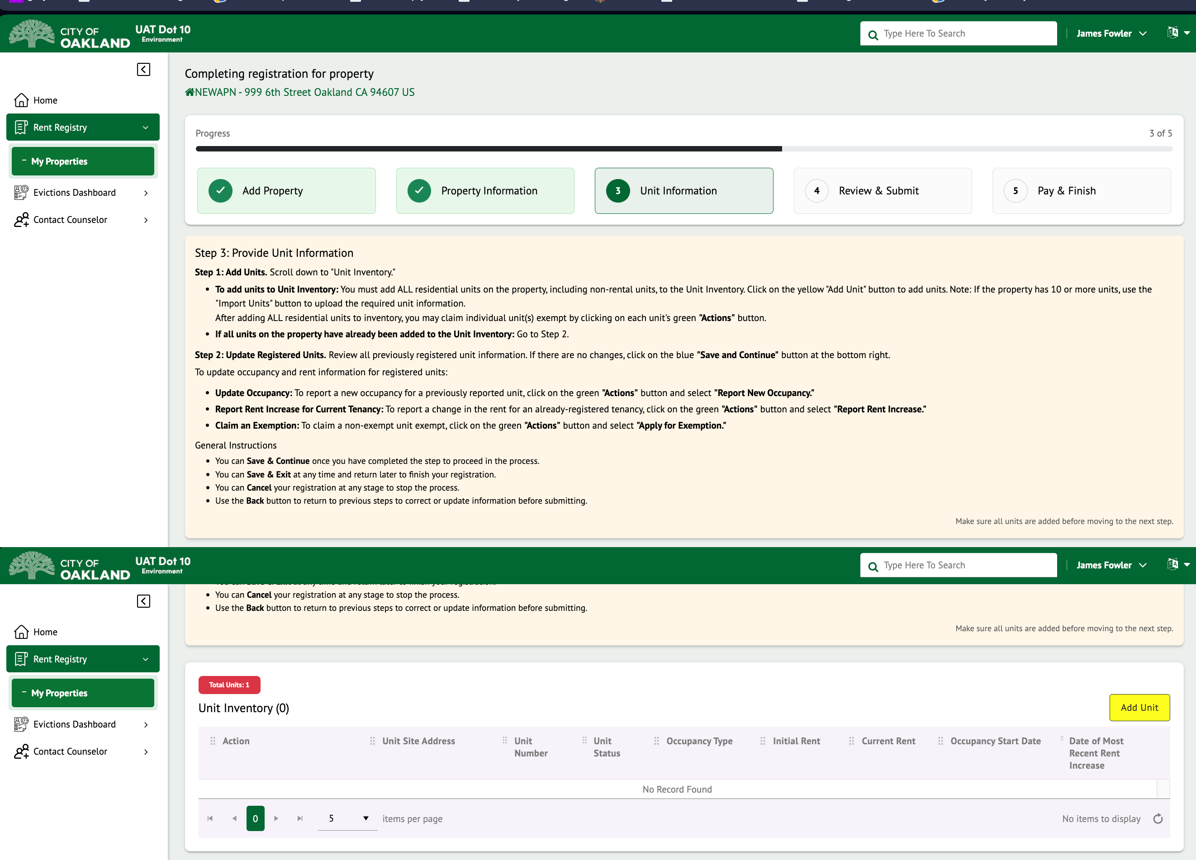

If the Total Units section is red, that means the number of units added on the property does not match the expected Assessor’s Unit count.

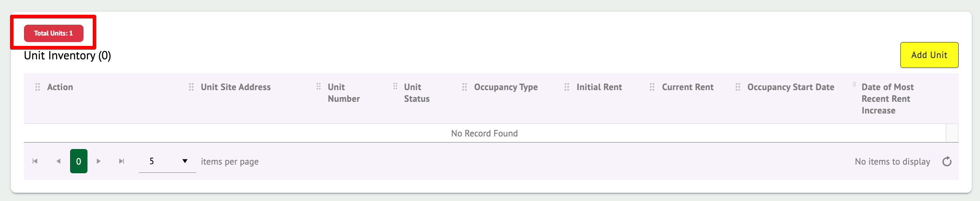

If the Total Unit section is green, that means the number of units added on the property matches with the expected Assessor’s Unit count.

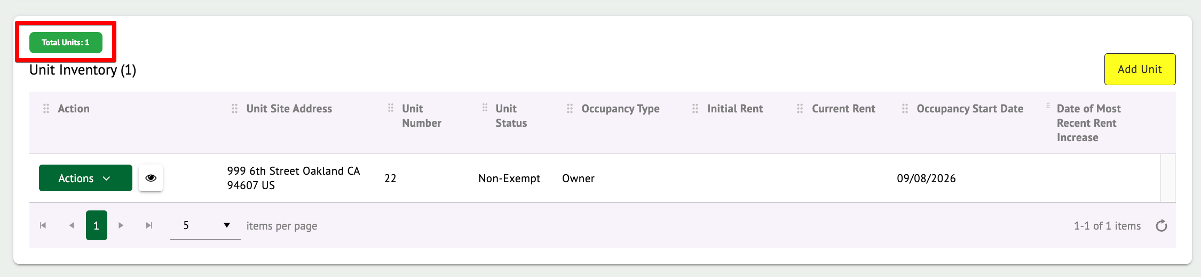

Add a new Unit

To add a fresh unit, click on the yellow “Add Unit” button.
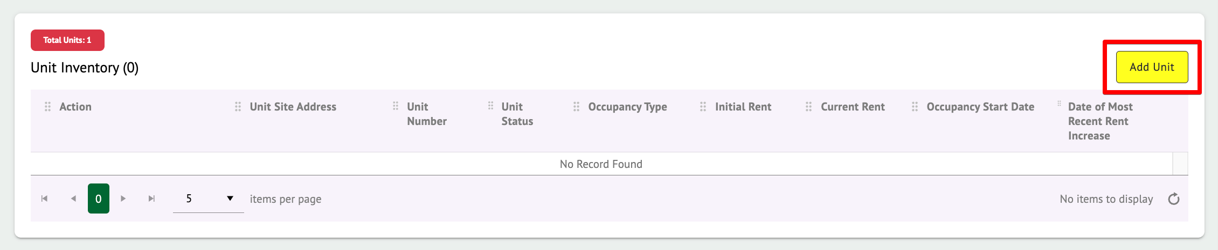

The Add Unit form will appear.

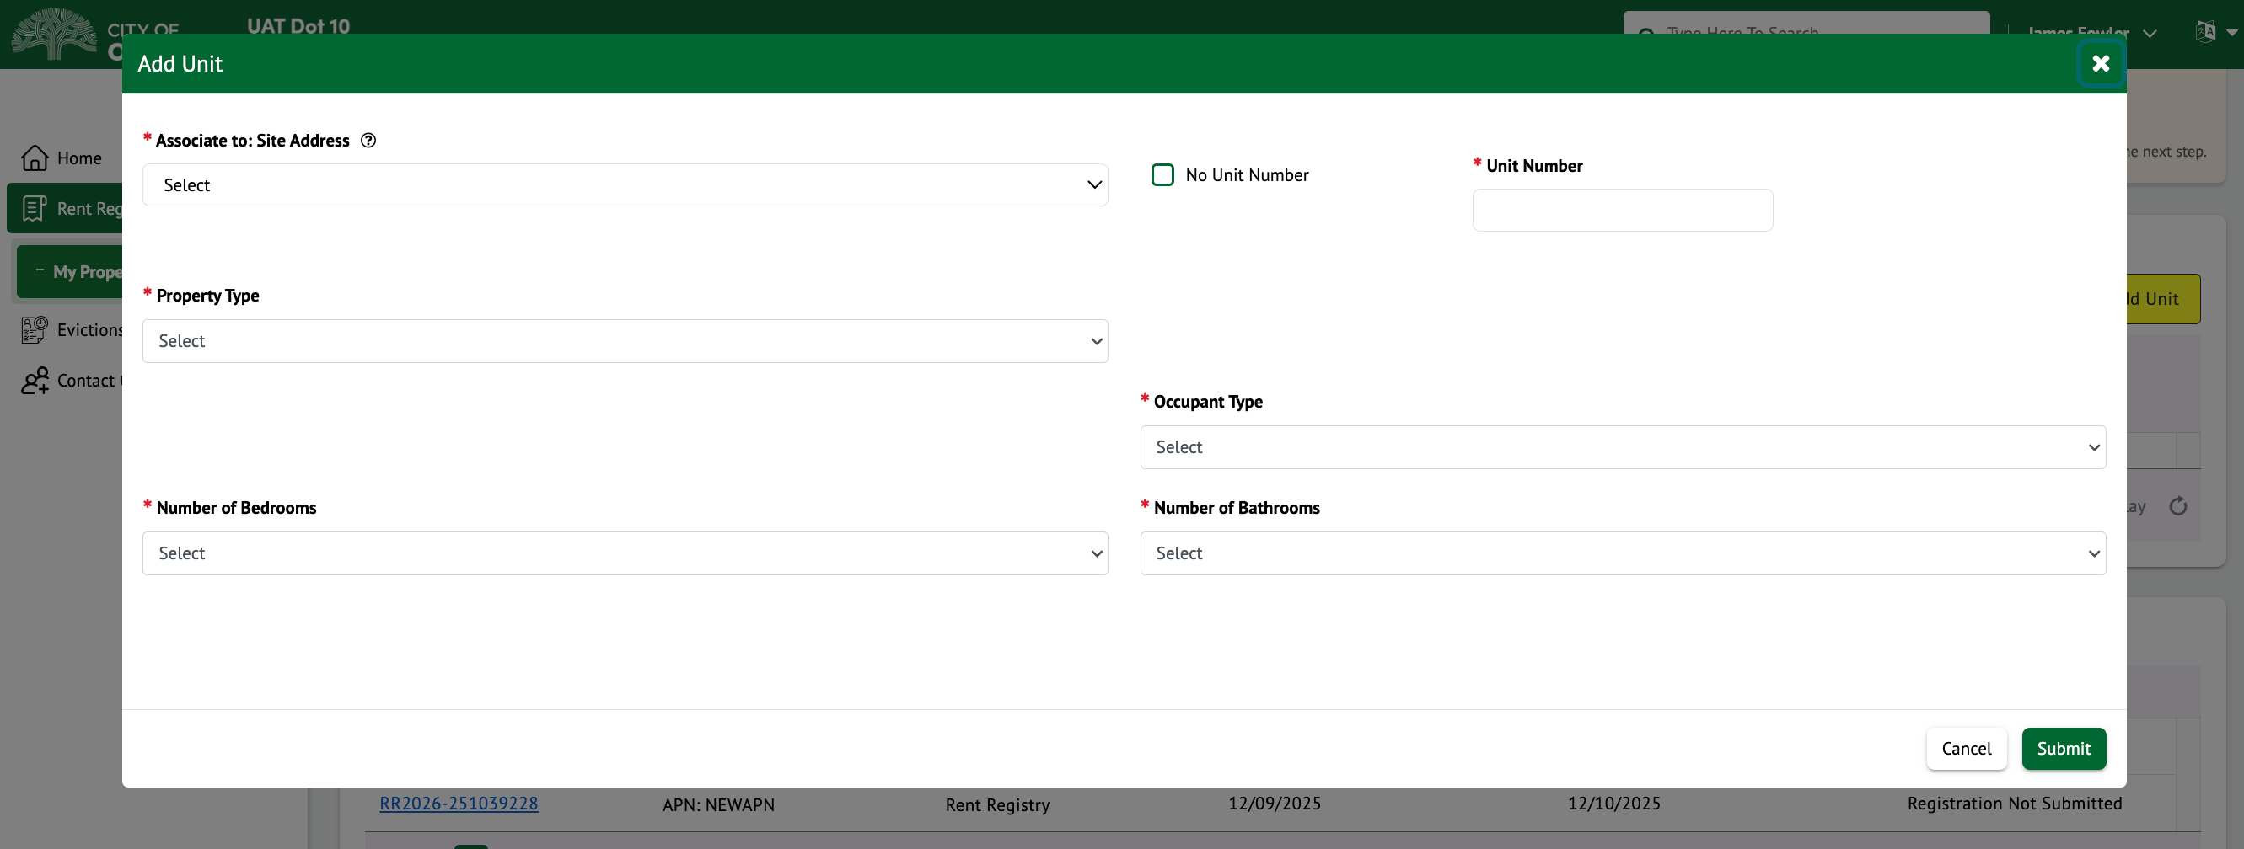

First select the Site Address for this unit. The Site Address represents part of the unit’s mailing address. If the unit’s site/mailing address is not present, you can go back to Step 2 and add an additional address to the property. The list will contain only those addresses added to the property.

Next, enter the Unit Number. Some units may not have a specified number (i.e., A, 2B, etc.). If so, click on the ‘No Unit Number’ checkbox.

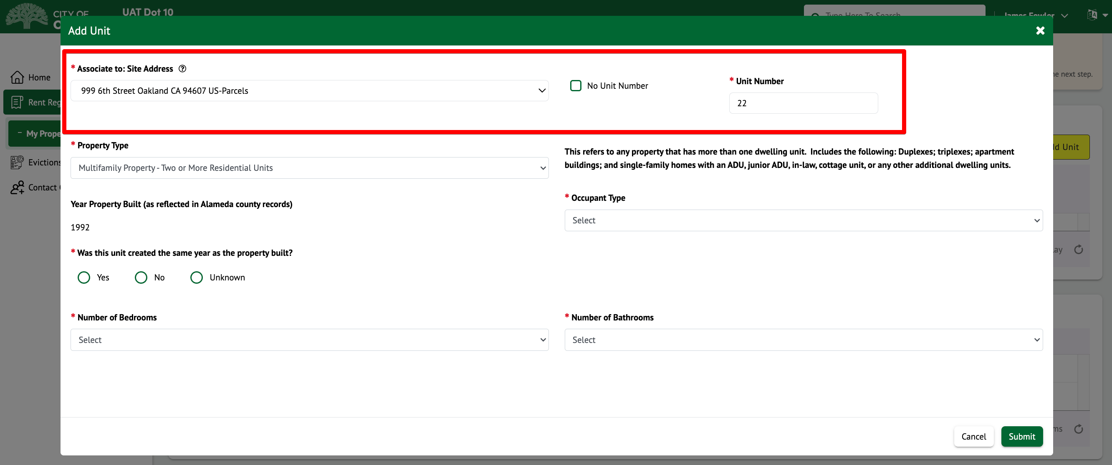

Then select the Property Type from the dropdown list. Depending on the property type selected, additional fields will appear on the screen. Any field that contains a red asterisk (*) means the information is required. Ensure all the required information is present and click on Submit.

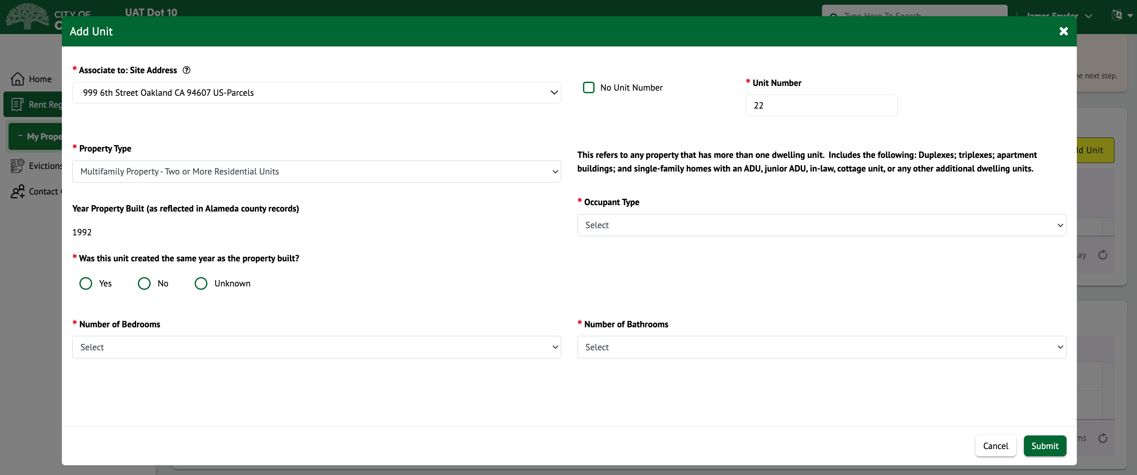

Then select the “Occupant Type” from the dropdown list. Depending on the occupant type selected, additional fields will appear on the screen. Any field that contains a red asterisk (*) means the information is required. Ensure all the required information is present and click on Submit.

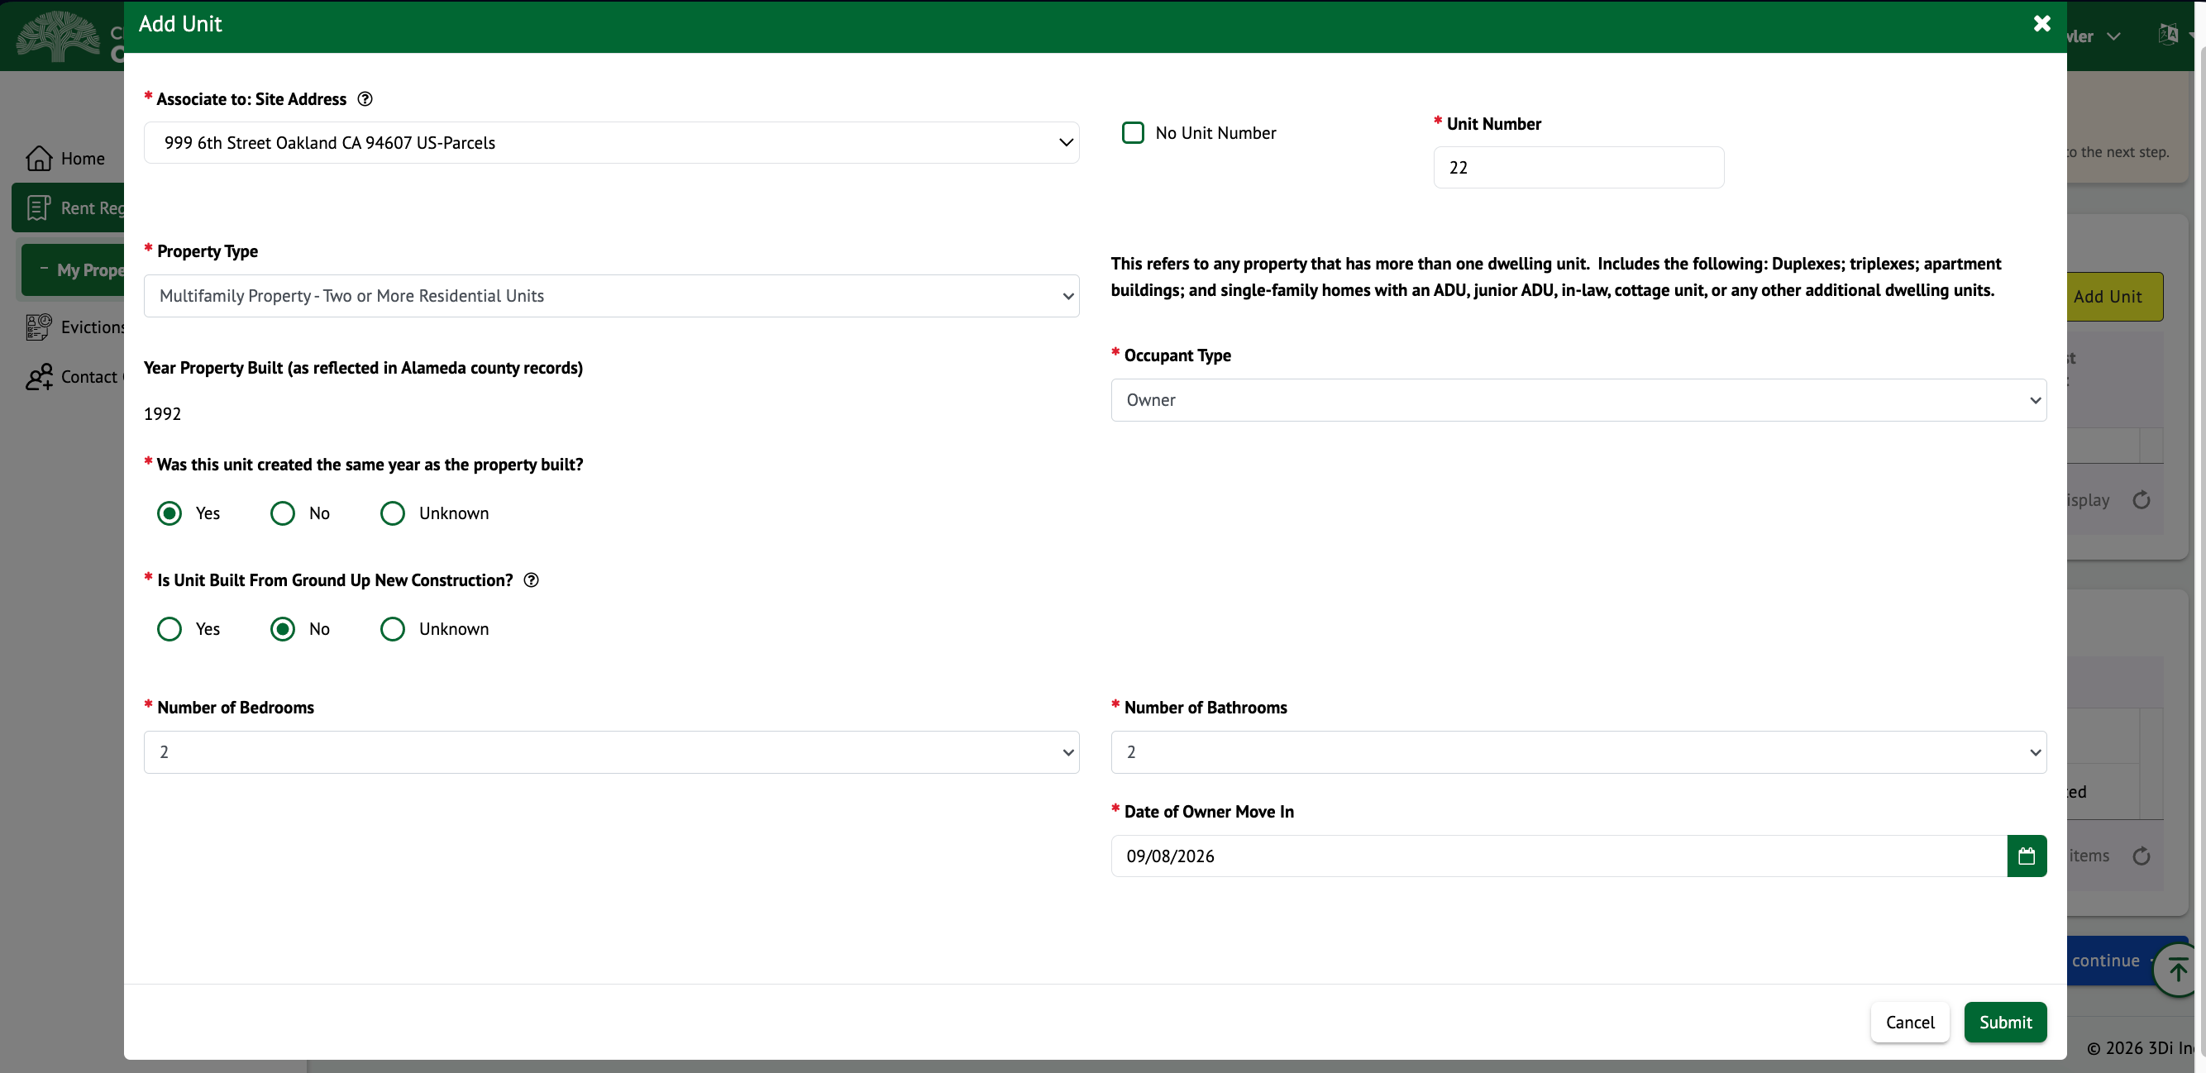

The newly added unit(s) will appear in the Unit Inventory grid and will contain an Action menu for additional options.

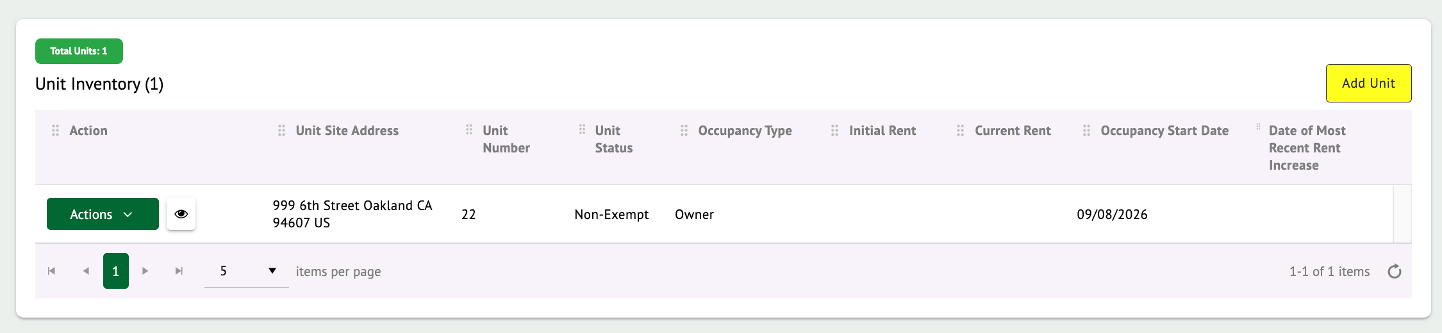

Unit Actions/Cases

During the registration process (and throughout the year), updates to units may be necessary. To submit updates/cases against any existing units, click on the “Actions” button and then select from the list of actions that you can perform.

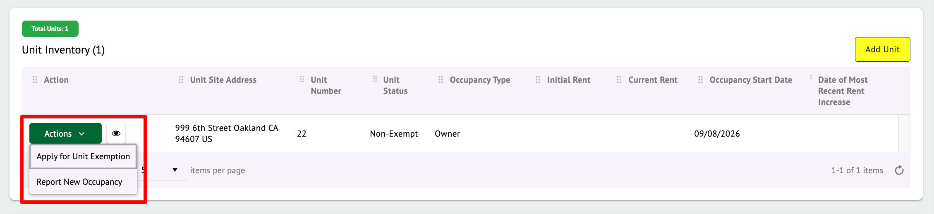

The list of available actions may differ depending on a few factors like the Occupant Type, Unit Status, and/or the property’s Registration status. However, below is a list of cases/actions that can be performed against units.
- Apply for Unit Exemption
- Report New Occupancy
- Report Rent Increase

When an action is selected, a pop-up will appear for you to enter the relevant information. Any field which contains a red asterisk (*) means the information is required. Ensure all the required information is present and click on Submit.
Note: Most submissions of these actions/cases will require Staff review before you see the updated information.

Unit Exemption

Review the City of Oakland’s Rent Registry Department Ordinance to determine if your unit qualifies for an Exemption. If the unit qualifies for an Exemption, you are encouraged to submit a Unit Exemption. Staff will review each Unit Exemption that is submitted and determine if the Exemption is approved or denied. This will be apparent through the Unit’s Status. By default, all units are listed as ‘Non-Exempt’. If a unit exemption is submitted and approved, the unit’s status will be changed to ‘Exempt’.

To apply for a Unit Exemption, click on the “Actions” button and then select ‘Apply for Unit Exemption’. If the unit’s status is already ‘Exempt’, then you cannot apply for a new Unit Exemption.

Note: If you forget to apply for an Exemption, you may incur additional fees for Registration as the fee is calculated based on the number of Non-Exempt Units when registration is submitted on time.

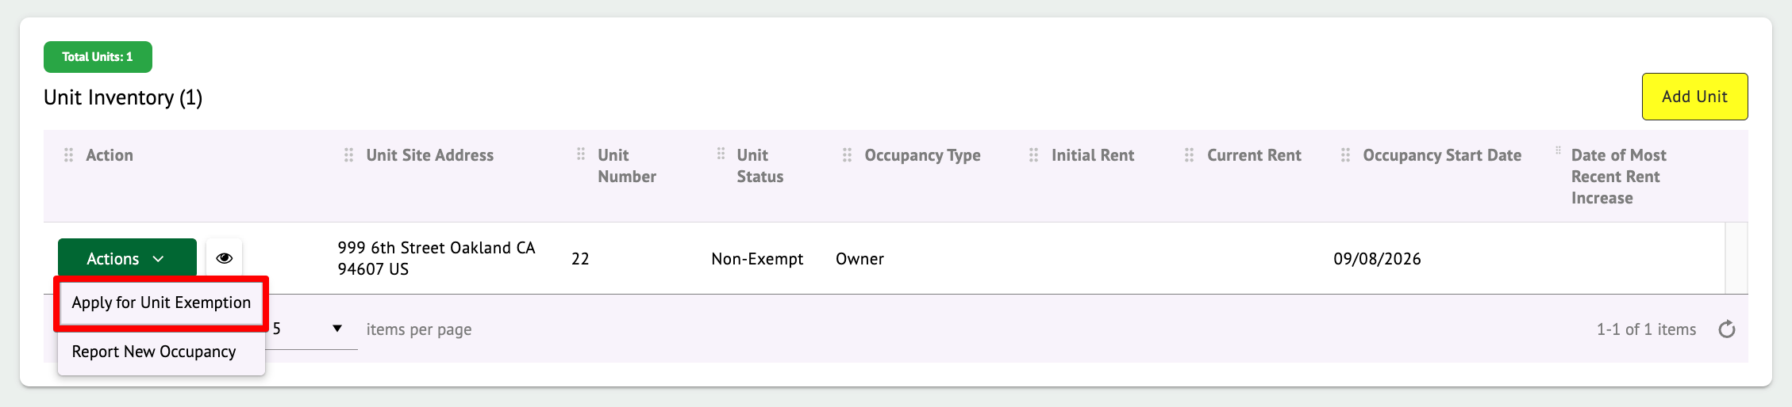

Once clicked, a pop-up will appear for the Unit Exemption submission.

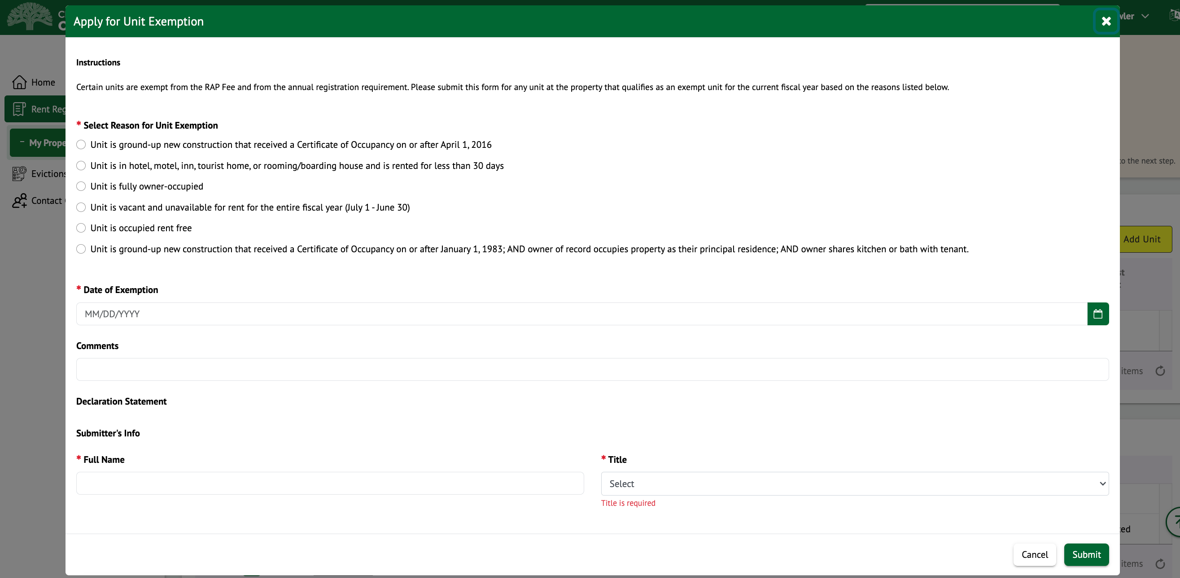

Any field that contains a red asterisk (*) means the information is required. Ensure all the required information is present and click on Submit. A case number will be generated upon successful submission. You can click on “Ok” to close the pop-up.

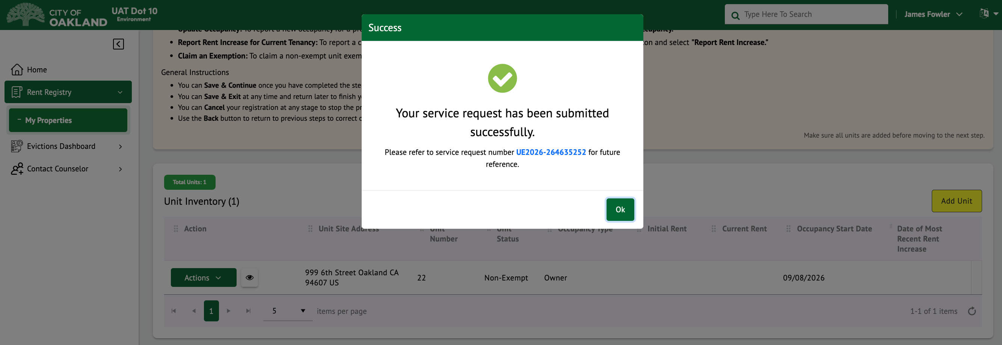

The Unit Inventory and Cases section will also show that a Unit Exemption was submitted. Staff will need to review and approve or deny the Unit Exemption.

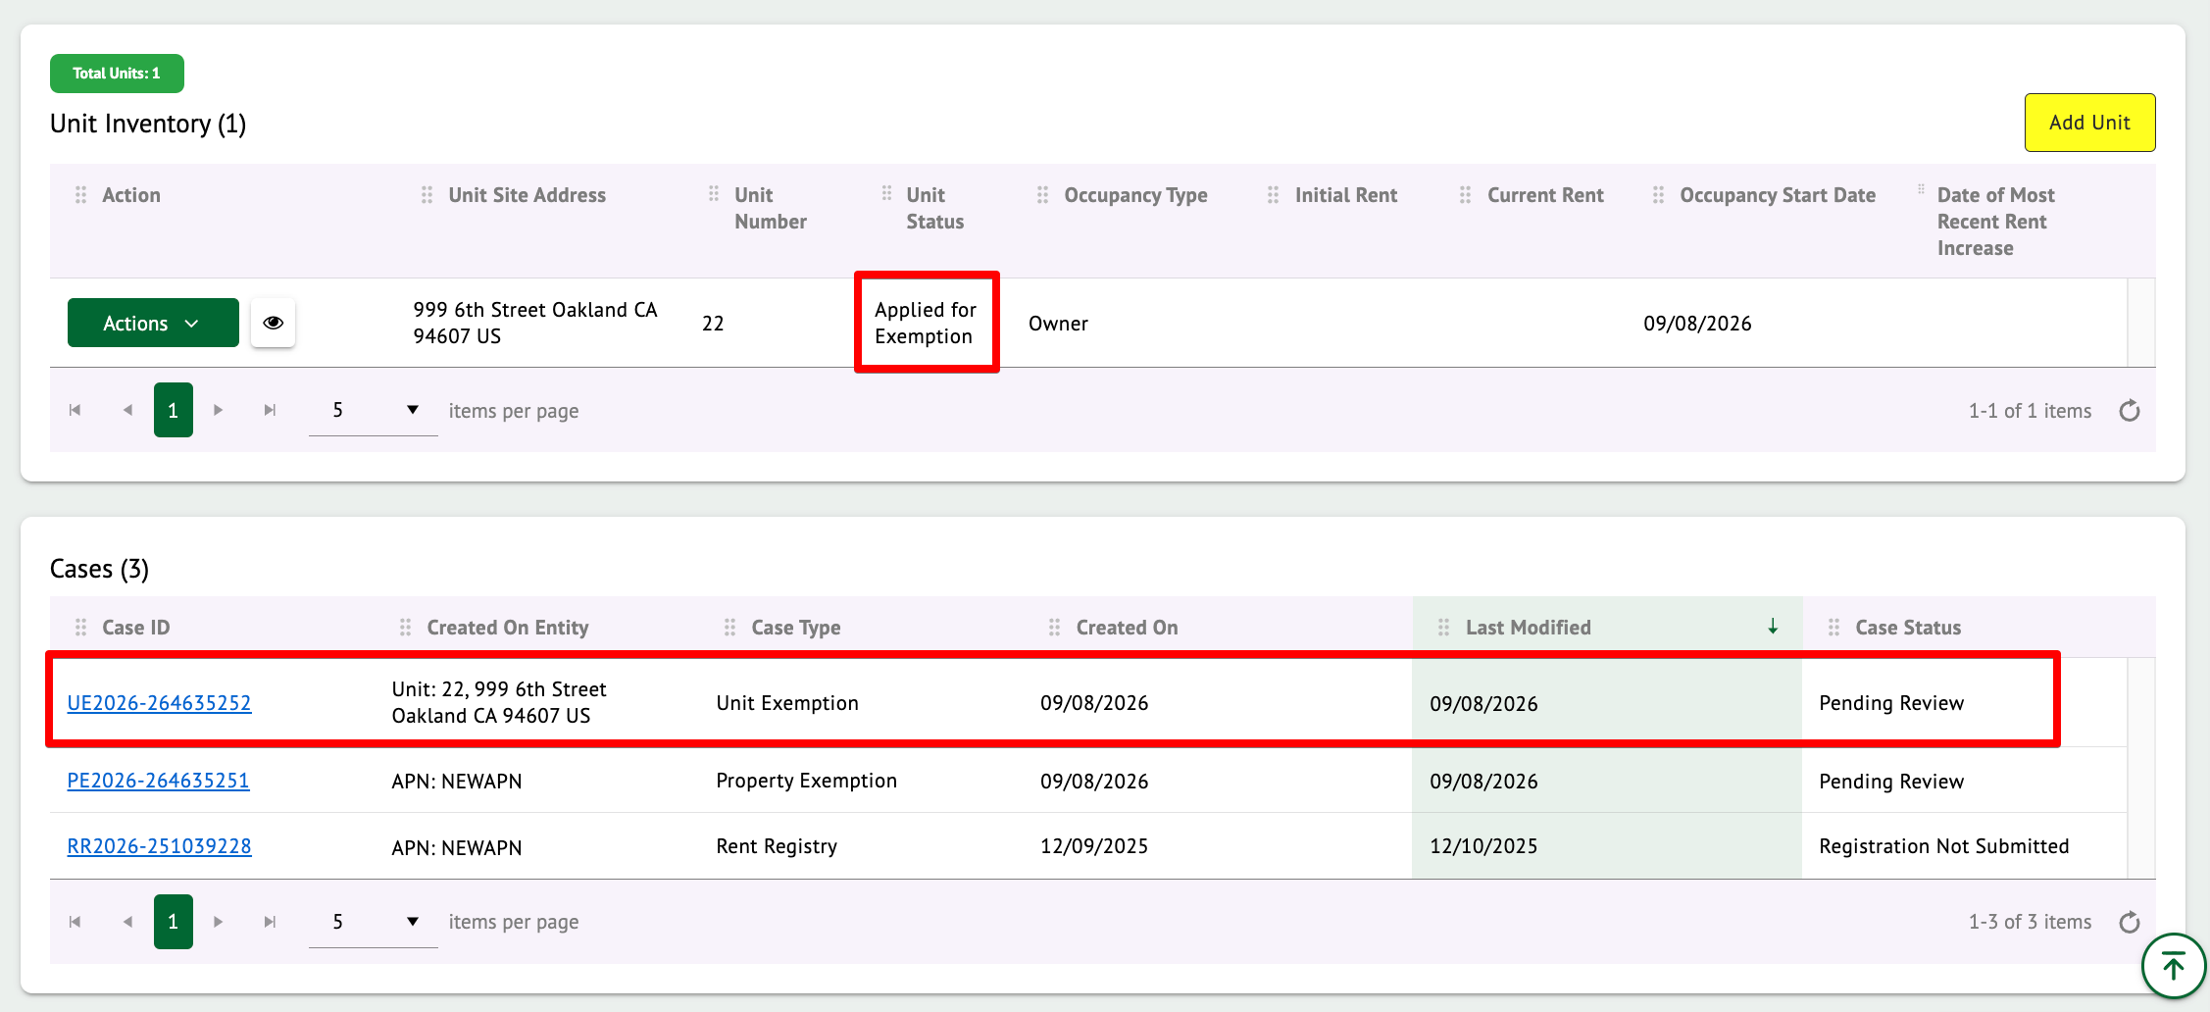

You can apply for Exemptions, one unit at a time, as required.

Note: Even if you have submitted a Unit Exemption(s), you still must continue to complete the registration process and submit your property. Ensure all units are updated and then click on “Save and continue” to move to Step 4.

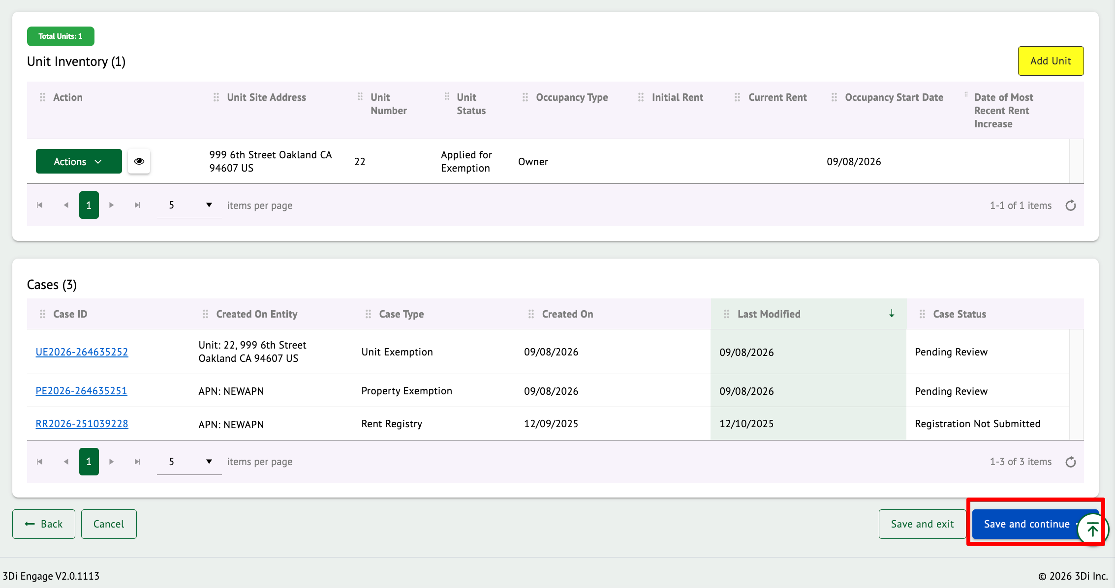

If the Unit Exemption is denied, the unit’s status will return to ‘Non-Exempt’.

If the Unit Exemption is approved, the unit’s status will change to ‘Exempt’.

You will receive an auto-generated email from the system once the Unit Exemption is submitted and once a determination has been made by Staff.

The sample email has been displayed below.

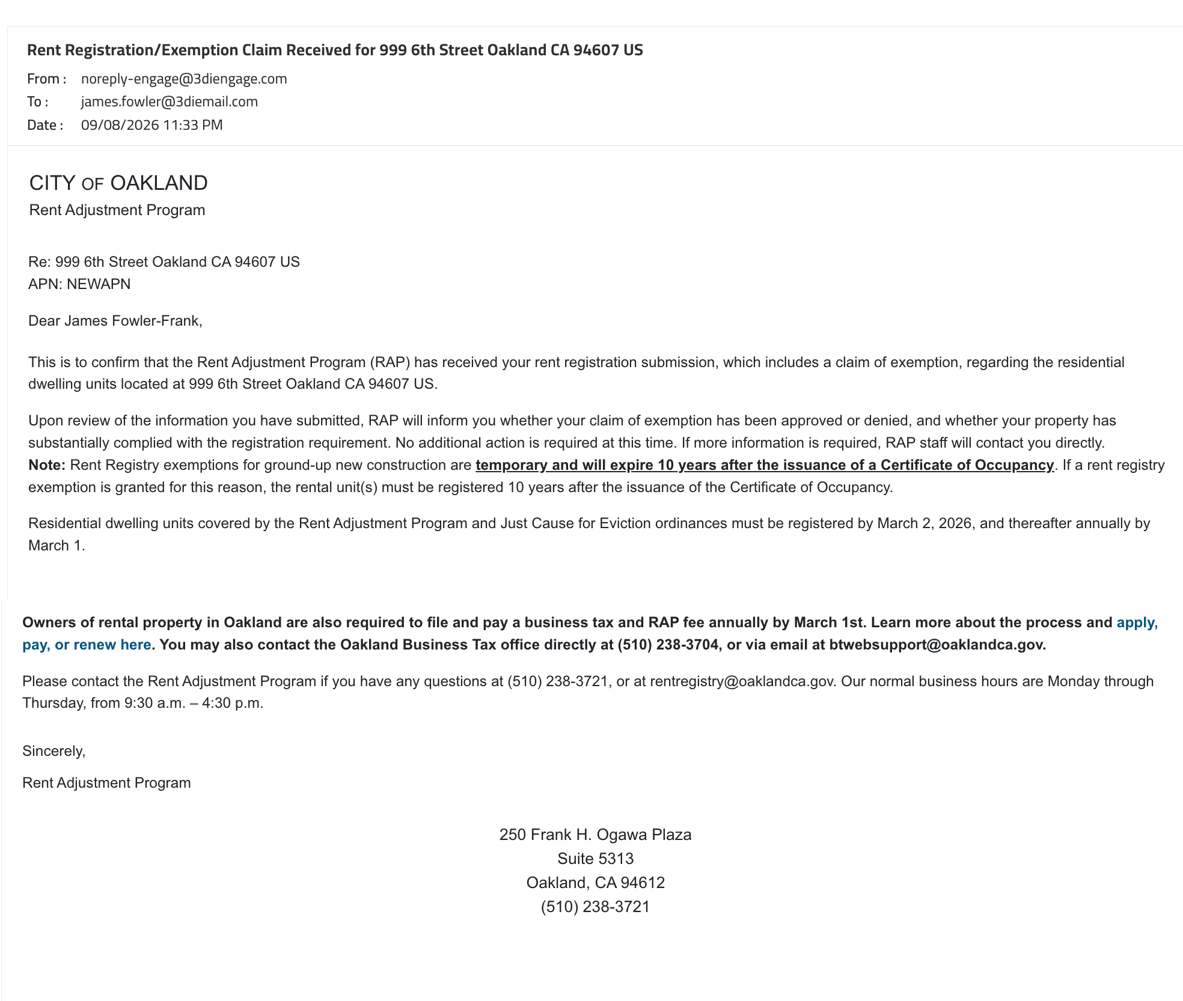

Step 4 - Review and Submit for Registration

This section describes how to submit your Property for Registration. You should have applied for all Exemption requests PRIOR to completing this next step.
Review all the instructions at the top of the page. As you scroll down, take note of the unit’s details and the contact information.
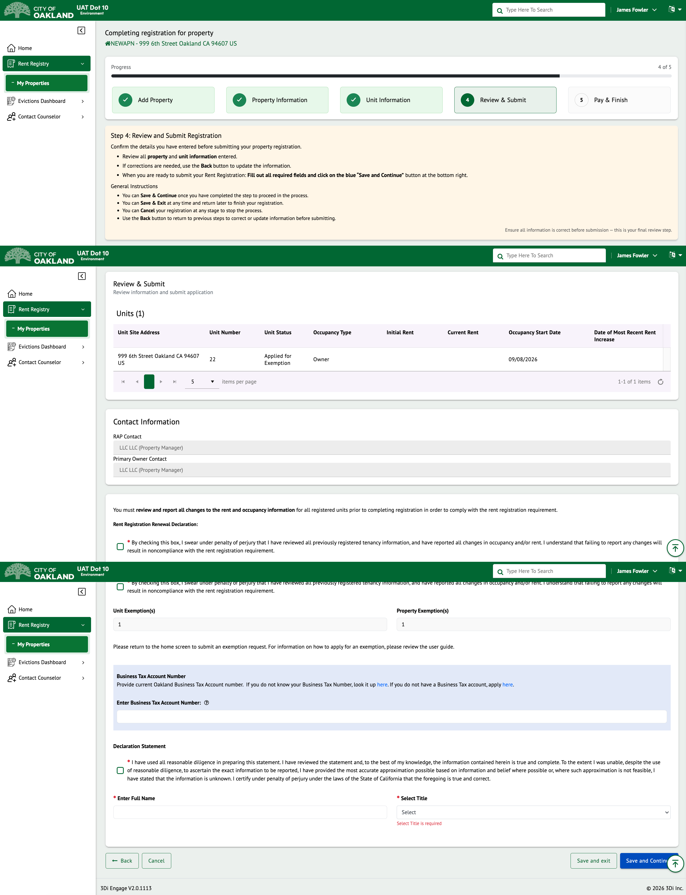

Scroll down to the Exemption section to review the number of exemption requests either submitted or granted for the property and units. If you confirm everything has been submitted, click on the checkbox as shown below.
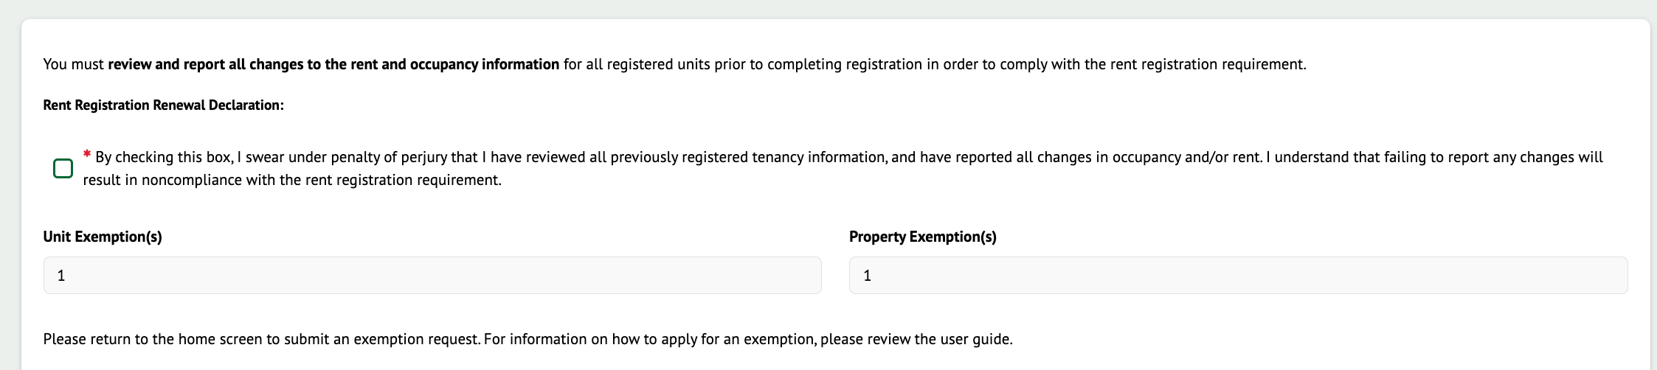

Next, enter the Business Tax Account Number, if applicable and follow the instructions as shown below.

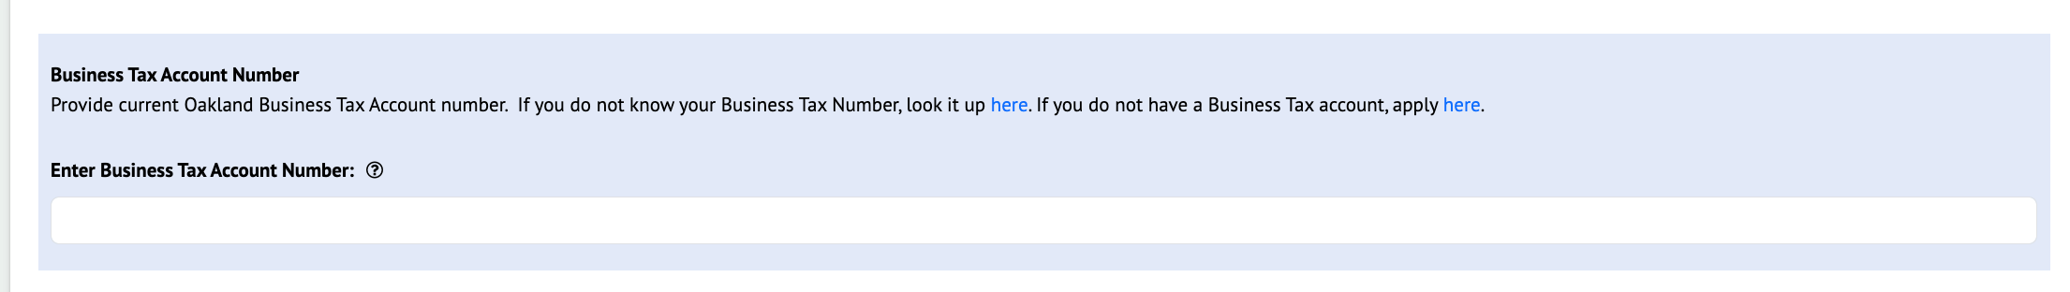

Review the Declaration Statement and confirm by clicking on the checkbox. You must also enter your Full Name and select your Title as shown below.

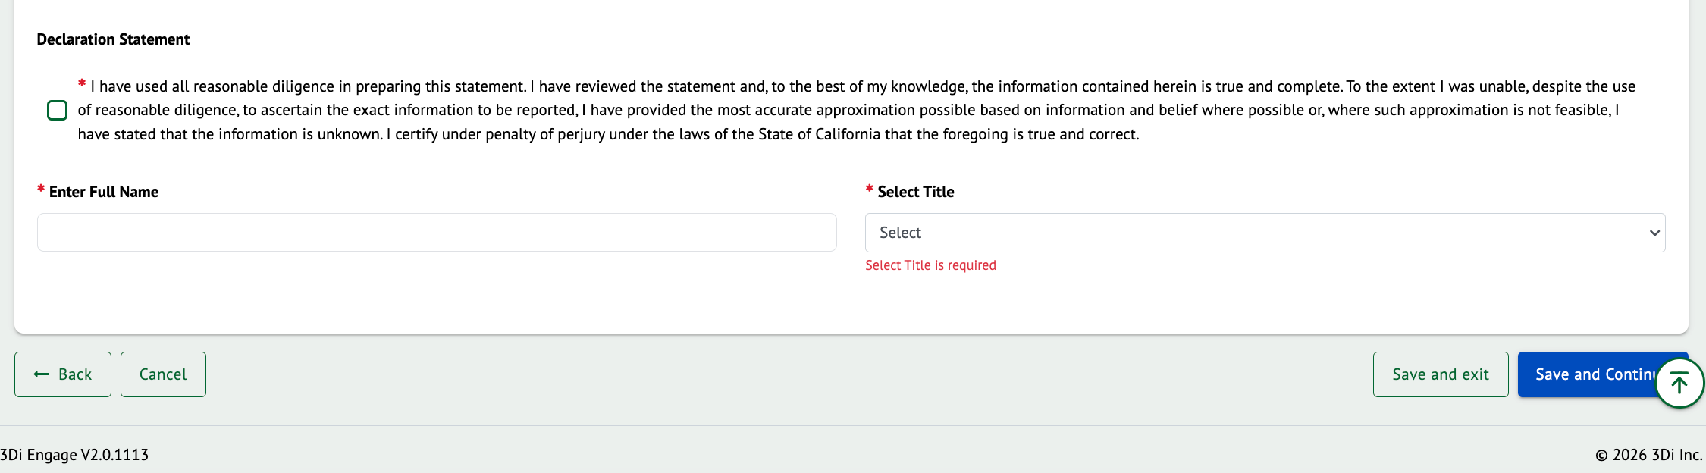

If you are ready to submit, click on the “Save and Continue” button to move to the final step.

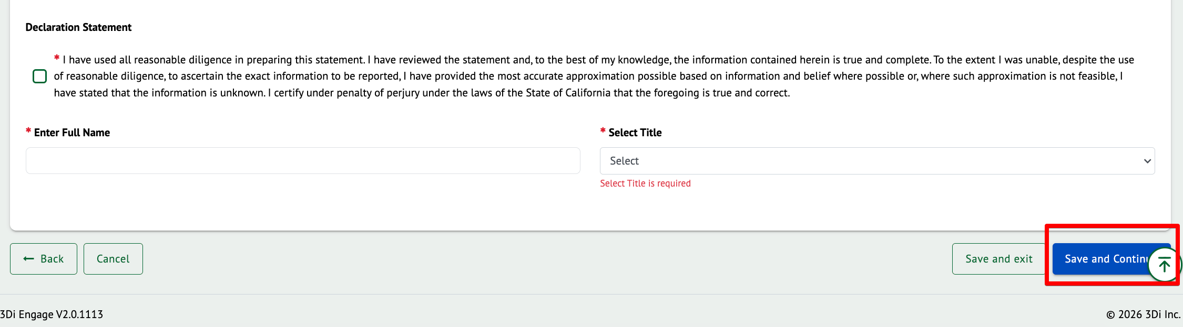

Once submitted, you will move to Step 5 where you can scroll down to see a ‘Registration Submitted Successfully!’ message along with your current property status.

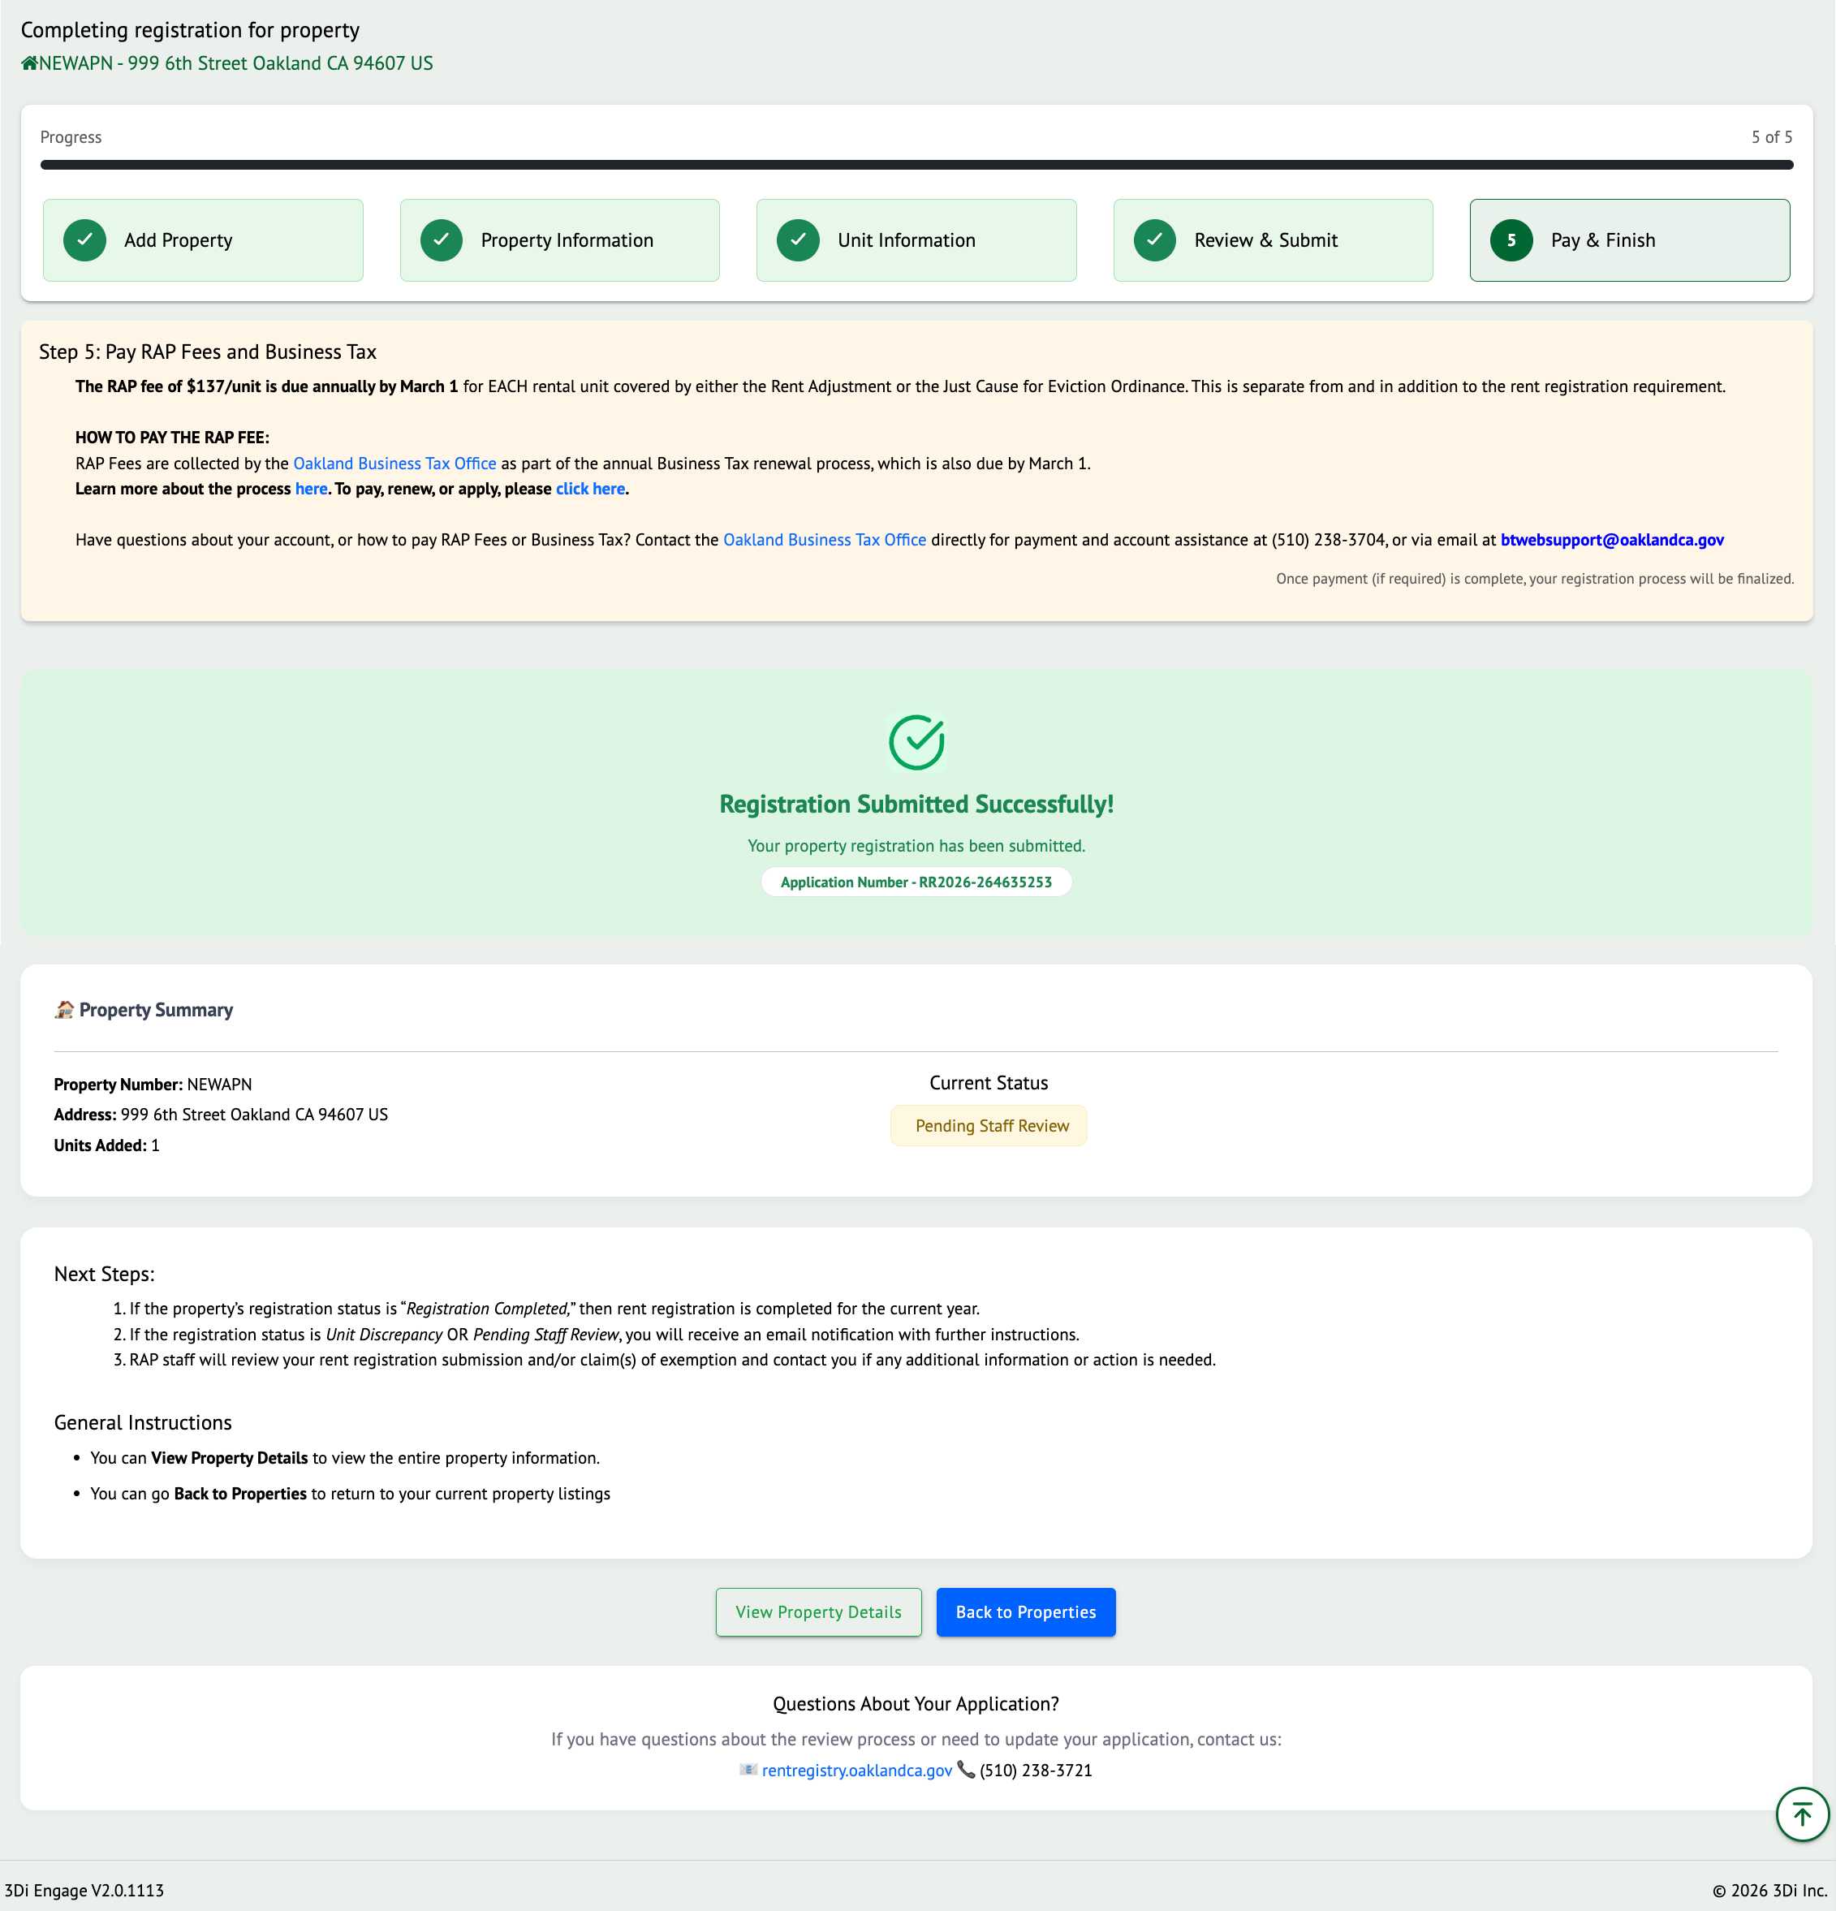

Below you will find a list of property statuses and their meaning. This will help you identify the next steps.

Status | Meaning
Registration Open | The registration period is open, and you need to provide updated information about your property and submit for registration.  You may have submitted a property exemption and are waiting for staff to review; your property may be in this status until your application is processed. Check the status of your Property Exemption case to ensure it is not denied. If so, you will be required to register.
Registration Denied | Your registration was submitted, but Staff denied it due to some errors or corrections. You will need to review your inputs, make necessary edits, and re-submit the property.
Unit Discrepancy | Your property has been submitted for registration, and the number of units you have added to the property does not match with the assessor’s records. Your property is flagged for Staff to review. You do not need to take any action. Staff will reach out if there are any questions.
Pending Staff Review | Your property has been submitted for registration, and there are exemption applications that still need to be reviewed by the Staff. You do not need to take any action. Staff will reach out if there are any questions.
Registration Completed | You have completed the registration of your property for the fiscal year by successfully submitting the property. You do not need to take any additional action at this time unless you have occupancy amendments or rent increases to report.
Property Exempt | You have submitted an exemption of your entire property, and it has been approved. You would not be required to pay any fees until/unless your property’s exemption status changes.

Unit Level Actions

During the Registration process, use the yellow Unit Action menu in the Unit Inventory section to submit cases to Report a New Occupancy, or Report a Rent Increase. Once the registration is submitted, you can continue to use the yellow Unit Action menu to report changes to the information throughout the year. In this section, we will describe some of the additional actions that can be taken against units.

Report New Occupancy

It is important to report New Occupancy to ensure that the Rent Program has accurate tenancy and rent information to monitor and enforce the Ordinance of the Program. This can be done through the “Report New Occupancy” unit action.

Follow the steps listed below when a new occupancy needs to be reported.

For the unit whose occupancy has changed, click on the yellow “Action” button and select the option of “Report New Occupancy”.
Depending on the current Occupant Type, the Action Menu options will differ from Unit to Unit.
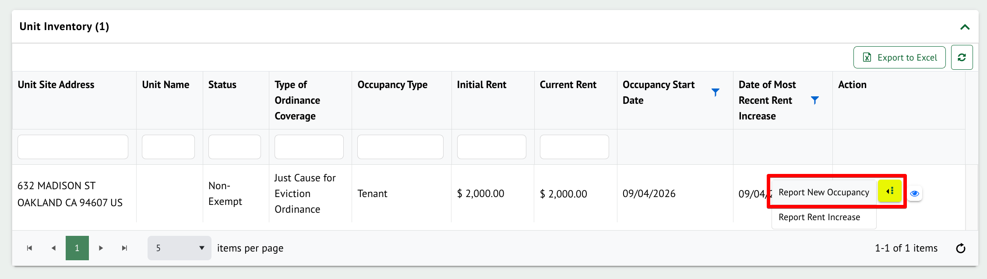

The Report New Occupancy pop-up will appear. Select the “Reason Previous Tenancy Ended” by selecting an option from the drop-down list.

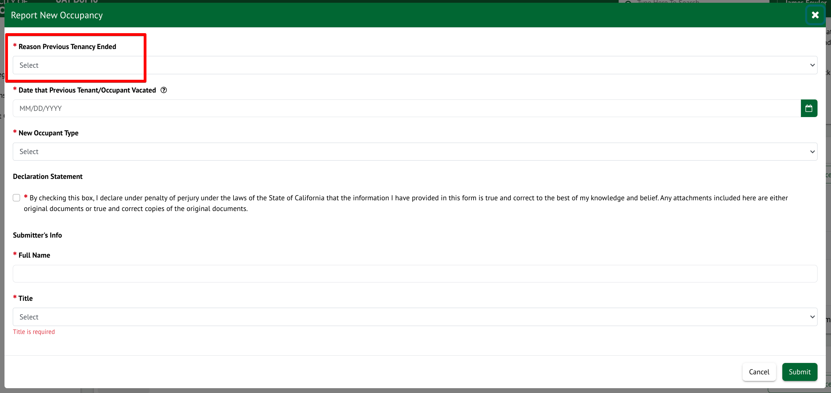

Select the “Date that Previous Tenant/Occupant Vacated”

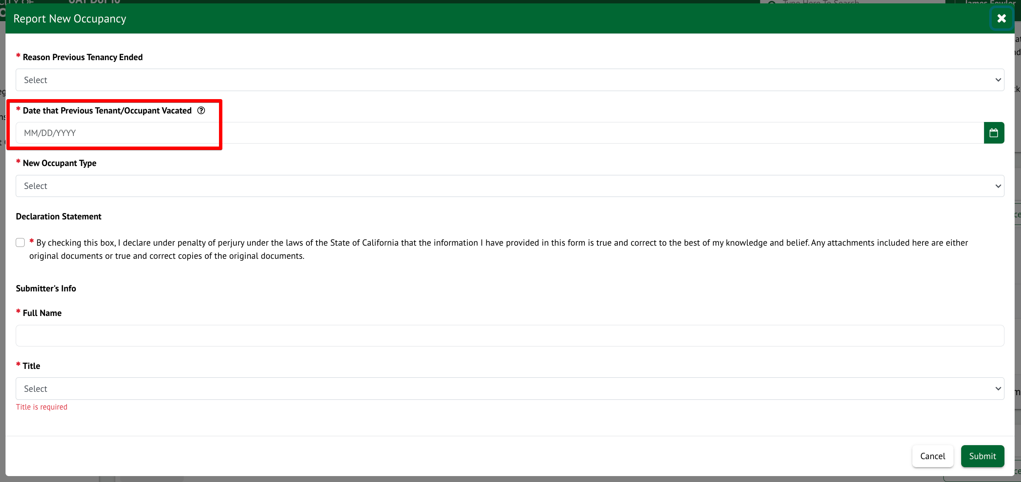

Select the “New Occupant Type” for the Unit. Once a selection is made, the required fields for the Occupant Type will appear. Any field which contains a red asterisk (*) means the information is required.

Double-check the data that was entered on the New Tenancy application for accuracy. Review and confirm the Declaration Statement. Ensure all the required information is present and click on Submit.

The My Cases section will be updated to include the New Occupancy Amendment case that was submitted, and
the status of the case will be “Approved”.

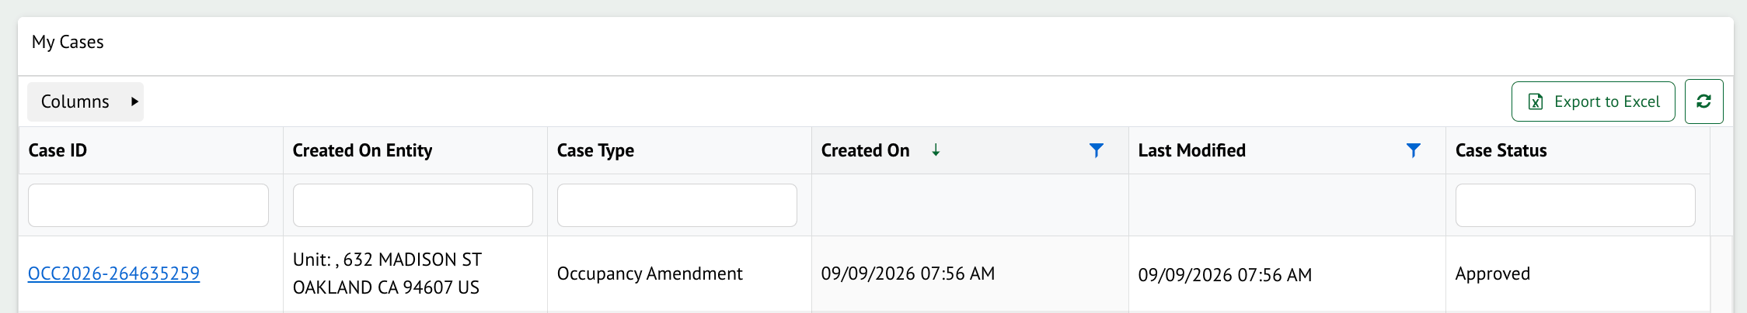

Report Rent Increase

If any unit’s rent has changed, users need to ‘Report Rent Increase’ to update the unit’s rent. There may be some cases where Staff will need to review the submitted information.

Follow the steps below to submit a change in rent for the current Tenancy.

For the Tenant-Occupied unit whose rent has increased, click on the yellow “Action” button and select the option of “Report Rent Increase” as shown below.

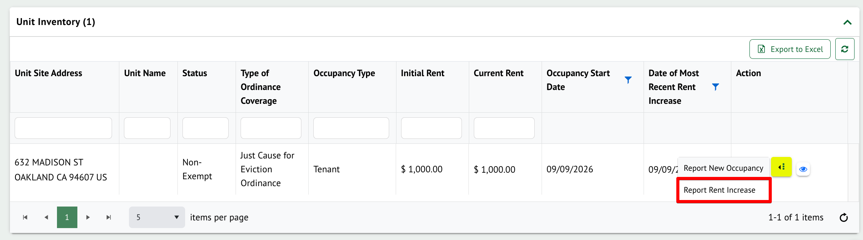

Enter all the required information and click on “Submit”.

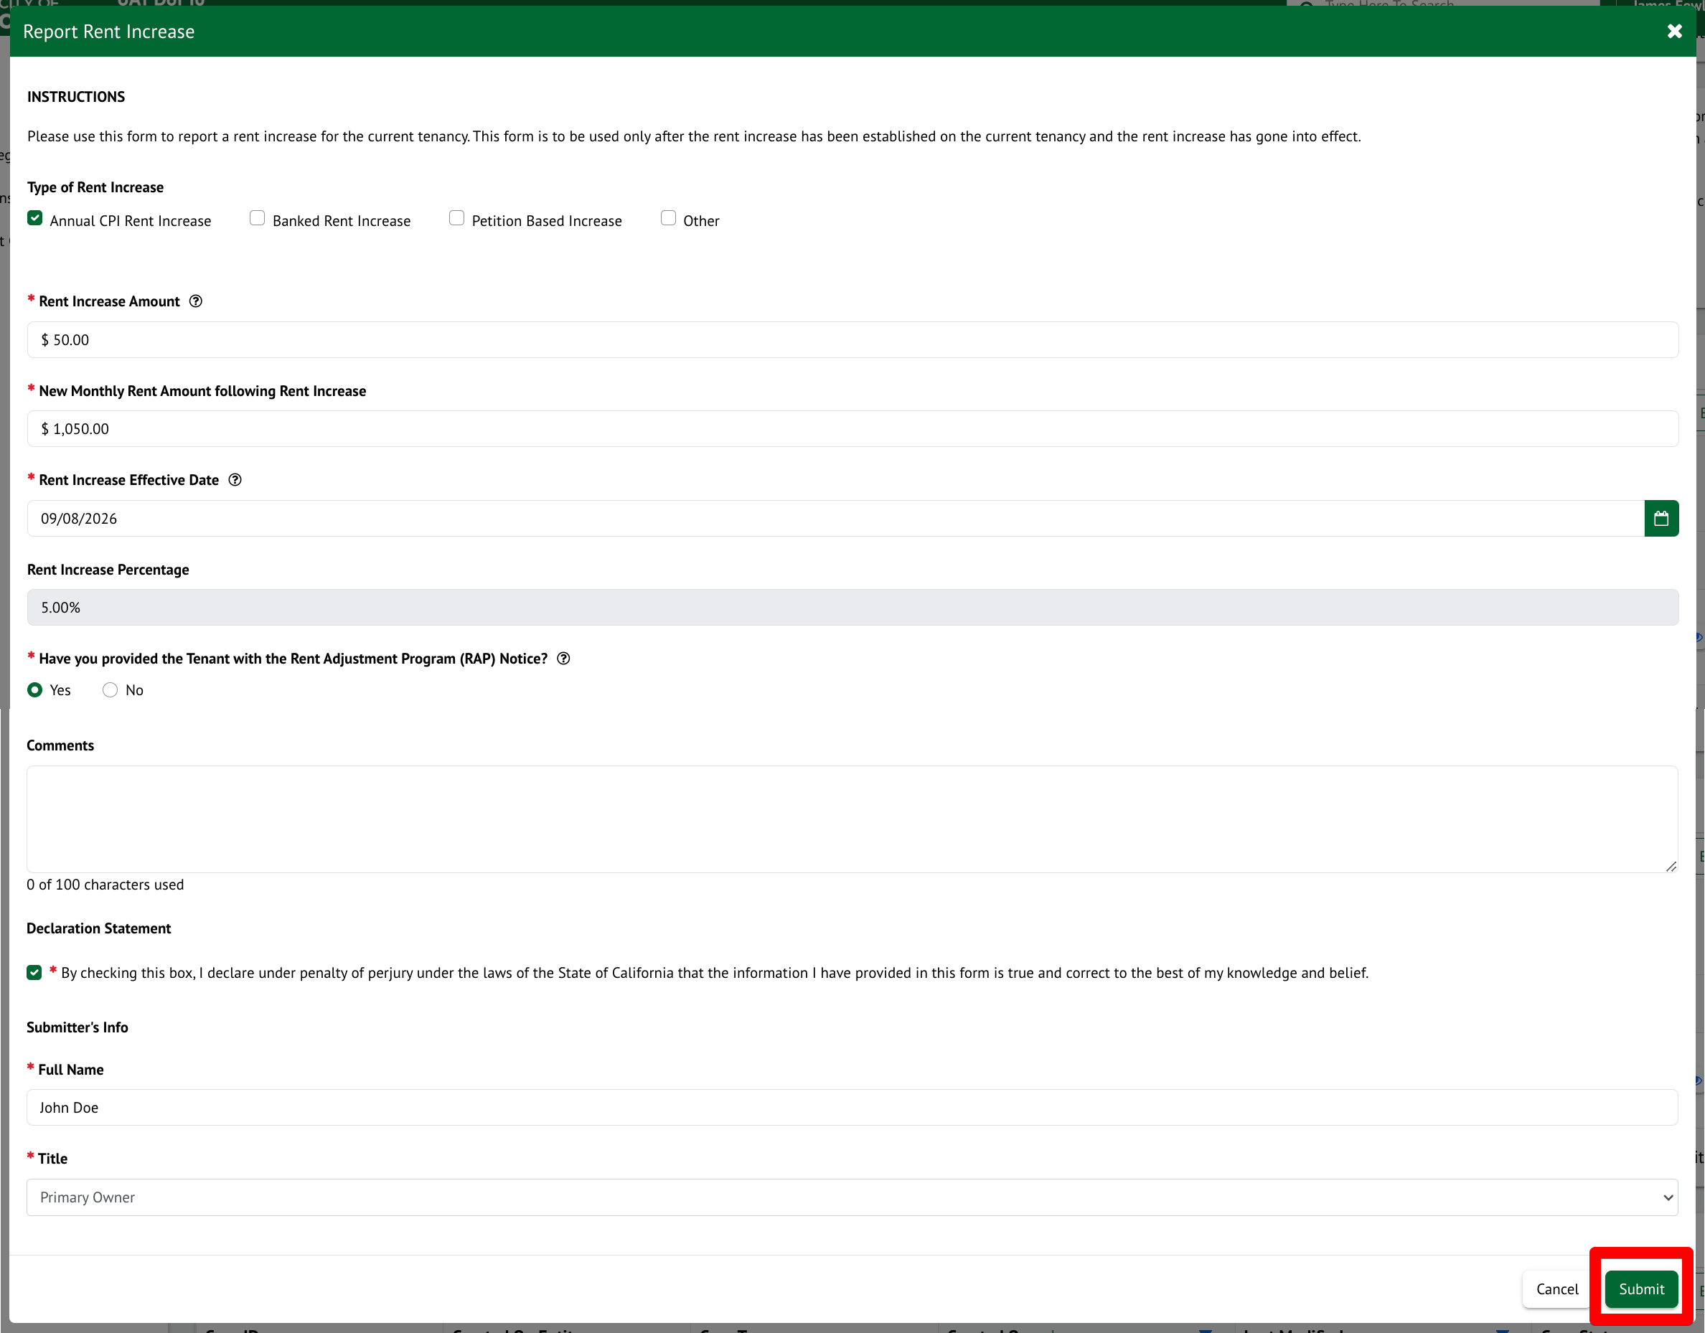

The Cases grid will be updated to include the new Rent Increase case that was submitted, and the status of the case will be “Approved”.

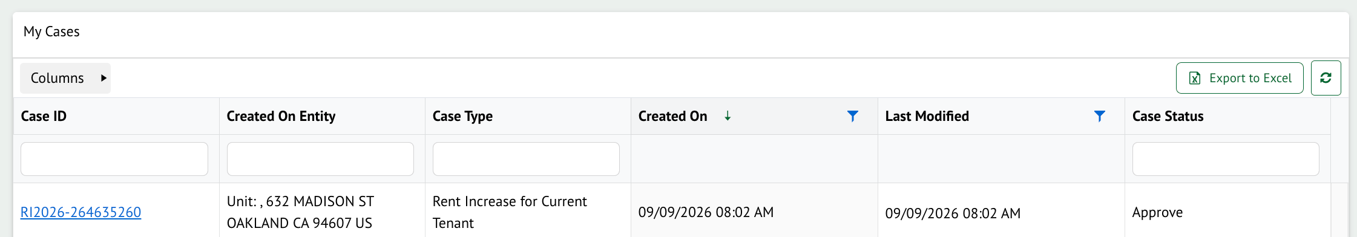

THANK YOU!

