**Principled Policing: The Mayor’s 2019 Q1 & Q2 Police Accountability Report**

Dear Oaklanders,

The genesis of the Oakland Police Department’s (OPD) ongoing reform effort is rooted in historical community distrust and harm caused by inequitable and racially disparate policing. Community relationships and trust are profoundly impacted when policing practices are influenced or are perceived to be influenced by bias, and when the public has concerns about whether there are meaningful internal controls on police power.

The purpose of this biannual report is to bring greater transparency to police data and outline how the City of Oakland’s Police Department (OPD) is managing and meeting its accountability goals. The City continues to work to meet both the spirit and the letter of its obligations under the Negotiated Settlement Agreement. The reports over time show a reduction of complaints, serious uses of force, and officer-involved shootings. In addition, the Department is working to fully staff the department, focusing on recruiting and hiring a diverse workforce with a range of experiences that reflect the people and the values of our community.

We need this community’s partnership to make Oakland the safe community it deserves to be, as well as delivering responsive and trustworthy government services. Please send your feedback and suggestions to me at [OfficeoftheMayor@oaklandnet.com](mailto:OfficeoftheMayor@oaklandnet.com).

Respectfully,



**Oakland Mayor Libby Schaaf**

**INTRODUCTION**

The purpose of this biannual report is to provide information to the public regarding police practices, particularly as it relates to subjects that have been of special interest to our community. The period covered by this report is January through June of 2019 and provides updates on the following subjects:

1. Trends in misconduct complaints and uses of force;
2. Department demographics;
3. Progress on the Negotiated Settlement Agreement; and
4. Oakland Police Department data collection.

**COMPLAINTS**

The practices, policies and procedures that govern OPD sworn and civilian employee conduct are set forth in the OPD Manual of Rules (MOR). OPD closely tracks, monitors and processes complaints. OPD investigates all misconduct complaints from any source (including anonymous complaints) against any member or employee. OPD's complaint acceptance policy can be viewed [here](http://www2.oaklandnet.com/oakca1/groups/police/documents/webcontent/oak069158.pdf). Additionally, the City’s Community Police Review Agency accepts complaints and conducts independent investigations. OPD closely tracks and monitors complaints against all employees and regularly reviews several risk factors, looking for early signs that individual employees, officers or squads need interventions, as well as searching for overall trends that suggest a need for new policies or training.

**COMPLAINTS 2012 – Q2 2019**

Although the trend has been downward since 2012, OPD has had a slight increase in complaints over the last two-year period. During this time OPD the numbers of calls for service and community contacts has increased, as well as an expanded definition of conduct that is categorized as a complaint. Between January 1 and June 30, 2019, 1,463 allegations concerning police services – including misconduct – were filed, resulting in 639 cases.[1] These charts represent complaints against all OPD employees, both sworn and professional staff members.

**Complaint Allegations January 2019 to June 2019**

The chart above shows the breakdown by type of the 1463 individual allegations contained in the 639 complaints received between January 1 and June 30, 2019.

The largest number of allegations (653, or 45 percent) are categorized as “Other”, which includes duplicate complaints and service complaints. Duplicate complaints are the same complaint against the same employee received more than once. Service complaints do not involve allegations of misconduct against specific employees, but instead pertain to concern or dissatisfaction with police practices that do not involve misconduct. For example, a complaint about a police action mandated by policy or law or delay in response to a call for service would be a service complaint.

“Performance of Duty” was the second most common type of complaint, with 31 percent of the total all complaints, and 55.5 percent of the complaints against specific employees falling into this category. An allegation of “Performance of Duty” occurs when it is alleged that an employee did not perform his or her assigned duties and responsibilities as required or directed by law or departmental rule. Violations of performance of duty include the following:

* Intentional illegal search, seizure, or arrest;
* Unintentional or improper search, seizure, or arrest;
* Failure to perform duties as required or directed by law, Departmental rule, policy, or order;
* Improper care of the property of persons; and
* Changing a work assignment without supervisory authority.

Use of Force (173, or 21 percent) and Conduct Toward Others (139, or 17 percent) are the two next largest categories of complaints against specific employees.

**Disposition of Individual Complaint Allegations January 2012 to June 2019**

Between January 1 and June 30, 2019, dispositions were reached on 1,485 cases involving complaints against OPD employees, both sworn and professional staff. Note - some of these cases were filed prior to January 1, 2019 but had completed dispositions during this period.

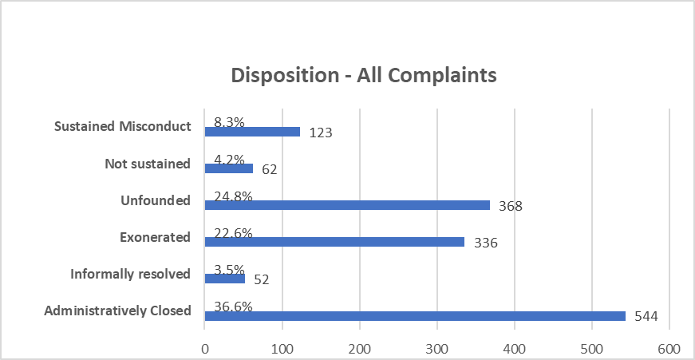

* **Sustained:** When an investigation discloses sufficient evidence to establish that the act occurred and that it constituted misconduct.
* **Not Sustained**: When an investigation discloses that there is insufficient evidence to sustain the complaint or fully exonerate the member.
* **Unfounded**: When an investigation discloses that the alleged acts did not occur or did not involve department members. Complaints determined to be frivolous are classified as unfounded.
* **Exonerated**: When an investigation discloses that the alleged act occurred but was justified, lawful, and/or proper.
* **Informally Resolved**: OPD provides for an Informal Complaint Resolution (ICR) process. This is when a complainant agrees to have a subject employee’s supervisor sit down with the employee for training, policy review, and/or a discussion of alternatives to handling whatever matter led to the complaint. The ICR is documented in the subject employee’s electronic file and the IAD control file.
* **Administratively Closed**: The complaint was based on a service complaint or the investigation could not or should not proceed. These include the complainant withdrawing the complaint; the affected OPD employee separating from employment; a failure of the complainant to identify an act or omission that would constitute a MOR violation; or a service complaint. Some of the cases filed in the period of January 1 to June 30, 2019 were still in progress and did not have a finding yet during this period.

**Disciplinary Decisions for Sustained Cases January 2019 to June 2019**

For sustained allegations of misconduct, discipline ranging from counseling/training to termination may be imposed. During this review period there were 111 sustained case discipline decisions. The most common discipline imposed for Q1 and Q2 2019 was a written reprimand (40 percent); followed by counseling/training (36 percent); and suspension (26 percent). There was one termination in the first half of 2019. OPD uses a matrix for each type of violation and considers aggravating and mitigating factors in coming up with the appropriate discipline.

**Trend in Sustained Cases**

Beginning in 2018, there has been an increase in sustained findings and discipline imposed.

**Complaint Policy and Training Recommendations**

In April of 2016, OPD began formally tracking all policy and training recommendations that resulted from Internal Affairs investigations. If a recommendation is urgent, it is addressed through an immediate policy change or training implementation. If not urgent, the recommendation may be included in the next regular policy rewrite or regular training. For the first half of 2019, these recommendations included:

* Have OPD host interview and interrogation training.
* Continue to update policy to emphasize the recognition of additional factors that may necessitate the use of force beyond the three most identifiable Graham factors.
* Continue to issue information bulletins to remind commanders and supervisors of the roles and responsibilities during critical incidents.
* Begin the OPD Race and Equity Academy training. OPD staff members at all levels, both sworn and non-sworn, will participate in Race and Equity Academy training workshops provided by the City of Oakland’s Director of Race and Equity and create equity teams within OPD.
* Continue to update racial profiling policy to include contemporary definitions of racial and identity profiling.
* Continue to develop policy to reflect evolving standards of reportable uses of force.

**USES OF FORCE**

OPD categorizes use of force in four levels:

Level 4: (most common – lowest level of force)

* A firearm intentionally pointed at a person
* An on-duty firearm discharge to dispatch an injured animal
* A Weaponless Defense Technique: hair grab, pressure to mastoid or jaw line, shoulder muscle grab
* A Weaponless Defense Technique Control Hold: escort (elbow), twist lock, arm-bar, bent-wrist

Level 3:

* Oleoresin Capsicum/Pepper Spray applied to a person
* The baton used for a non-striking purpose
* The use of a Taser
* A Weaponless Defense Technique: hand/palm/elbow strikes, kicks, leg sweeps, takedowns
* Any impact weapon w/o contact
* An on-duty firearm discharge at an animal

Level 2:

* Any strike to the head Any unintentional firearm discharge w/o injury
* Carotid restraint w/o the loss of consciousness
* Police canine bite
* Use of impact weapons w/contact
* Any use of force w/injury

Level 1:

* Any use of force resulting in death
* Any unintentional firearm discharge w/injury
* Any intentional firearm discharge at a person
* Any intentional impact weapon strike to the head
* Any force w/a substantial risk of causing death
* Any UOF investigation that is elevated to a Level 1
* Serious bodily injuries

The Oakland Police Department continues to make effort to reduce uses of force through increased training. During this period OPD increased classroom training to reinforce the legal and policy requirements for using force – even lower levels such as the pointing of a firearm at a person. OPD added additional dynamic training that includes simulated arrests, video simulators and role playing with non-lethal firearms as well as other force options. Additionally, more officers are getting trained in crisis intervention techniques with a focus on interacting with persons experiencing mental crisis.

**Uses of Force January 1, 2019 to June 30, 2019[2]**

From January 1 to June 30, 2019, there were 362 incidents in which force was reported. Although multiple officers may use force in the same incident, the data included in the chart represents incidents, and the incident is categorized as the highest level of force used. The force types break down as follows: one Level 1 use of force, due to a canine bite. (0.3%), 11 Level 2 incidents (3%), 43 Level 3 incidents (11.9%), 307, Level 4 events (84.8%).

**Officer Involved Shootings and Level 1 Uses of Force**

Any event that leads to an officer-involved shooting or serious use of force is traumatic event for both the public and the Department. The number of shootings and Level 1 uses of force has been declining. No OPD officer involved shootings or other type of Level 1 use of force occurred during this review period. [3]

**Force Review Boards:**

OPD conducts Force Review Boards (FRBs) and Executive Force Review Boards (EFRBs) to independently evaluate and review the force incidents. The Boards also make recommendations for policy or training changes. FRBs analyze and assess lower level use of force incidents. EFRBs analyze and assess Level 1 lethal use of force incidents, in-custody deaths, deadly incidents related to pursuits, and other incidents at the direction of the Chief of Police.

FRBs are comprised of three command staff members with the rank of Captain of Police or higher. EFRBs are comprised of three command staff members, at least one with the rank of Deputy Chief of Police who also serves as Board Chair. The other two members of the EFRB must hold the rank of Captain of Police or higher. The boards have two duties: 1) Determine whether the use of force complied with departmental policy; and 2) Identify any needed policy revisions identified from the investigation. In the first half of 2019, 12 boards reviewed 62 uses of force. The details of the force types reviewed in the boards are set forth in Chart C in the Appendix.

**DEPARTMENT DEMOGRAPHICS**

OPD continues to make progress to hire, train and retain a diverse workforce. Outlined below are the OPD demographics as of June 30, 2019. More detailed charts with further breakdown, including gender are included as Table D in the Appendix. In 2019 OPD embarked on several innovative locally focused recruitment campaigns. The next report will contain data showing the results of those efforts.

**STATUS OF THE NEGOTIATED SETTLEMENT AGREEMENT**

The City of Oakland's Negotiated Settlement Agreement (NSA) dates from January 22, 2003, when the City of Oakland and the Oakland Police Department entered into an agreement resolving allegations of police misconduct raised by private plaintiffs in the civil lawsuit, Delphine Allen, et al., v. City of Oakland, et al. The NSA requires police reforms in several areas, including data collection, internal affairs, supervision of officers, police use of force, training, personnel practices, and community policing.

The specific details of the reforms are embodied in the 51 enumerated tasks in the NSA. Currently, the City is fully compliant with 44 tasks, in partial compliance with 4 tasks, and out of compliance with 3 tasks. OPD receives monthly review and technical assistance from the Independent Monitoring Team on each of the tasks that remain to be completed. Details related to each task not yet in compliance is contained in the Appendix in Table E. The Department is working to achieve compliance with each of these tasks and develop sustainable internal processes and best policing practices.

Nearly all of the 50 recommendations in Stanford’s [Data for Change](https://sparq.stanford.edu/opd-reports) report that created strategies to address implicit bias and racial disparities in policing have been implemented. Forty-seven recommendations have been completely implemented. Of the three outstanding recommendations, two are related to the implementation of the updated data collection system that is described below, which is rolling out in phases and should be completely operational in the first quarter of 2020. The last recommendation relates to hiring a data manager/analyst for the Department to facilitate meaningful analysis of the data from the new data collection system when it becomes operational.

**DATA COLLECTION**

For many years OPD has collected data related to department activities, especially related to interactions with the public and employee activity and conduct. The collection systems and databases have evolved with technology from simple tools to a complex relational database. In late 2019, OPD will implement the latest iteration of their data collection system called “Vision” that will provide additional tools to capture and evaluate the data. This database includes details of police stops, complaints, uses of force, pursuits and accidents. The information collected in Vision assists supervisors and managers in managing employee performance. Reports from the system inform the Performance Assessment System (PAS) and the regular review of stop data. In 2020, there will be additional enhancements to the system that will provide state of the art interactive dashboards for supervisors to use in managing their reports and areas of responsibility.

OPD has collected detailed data every time a police officer makes a discretionary stop of a person. The “stop data” includes geographic and demographic data regarding each stop. Using tools and technical assistance from the Independent Monitoring Team and Stanford University, each month OPD analyzes the stop data and prepares reports for management review. In these “risk management” meetings, the department leadership reviews the stop data and discusses racial disparities or other concerning trends noted in the data. This review is done at many levels. The data is reviewed city-wide, by patrol area, patrol squad and individual officer level. Data from the system is also used regularly by OPD’s Office of Inspector General (OIG) in their audits.

In recent years, OPD leadership has used data to reexamine deployment strategies and expectations. In late 2017, directed officers to spend less time on low-level traffic and equipment violations and focus more on traffic safety and intelligence-led policing, a strategy that provides officers additional access to information to focus on specific criminal targets. As illustrated on the chart below, this direction has led to a signification reduction of number of discretionary traffic and pedestrian stops.

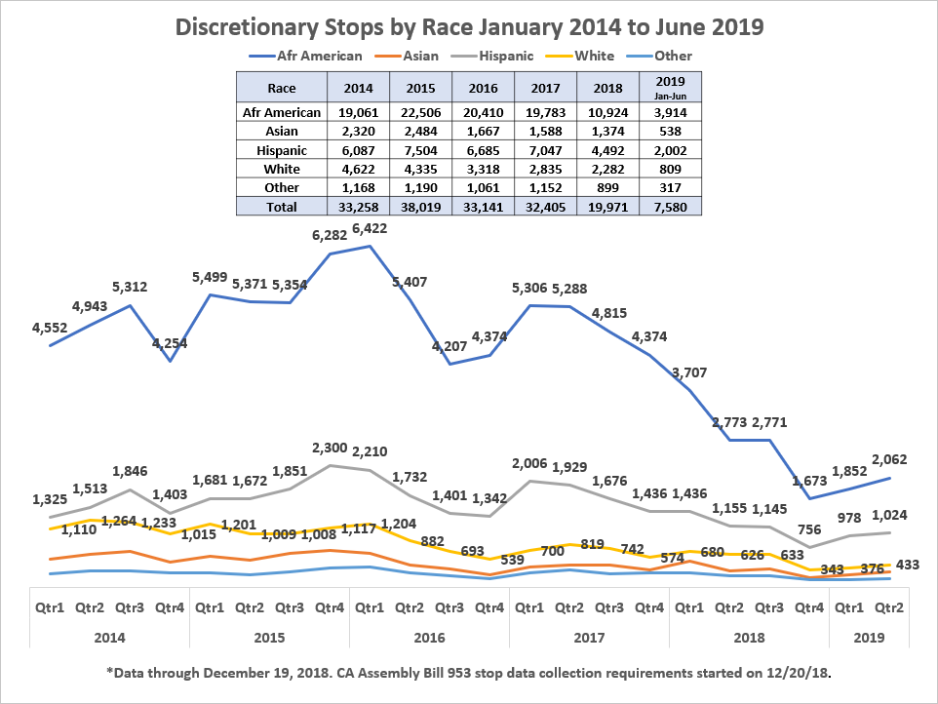

Information collected from police contacts informs our policies, practices, strategies and enforcement-related decisions. The detailed review of the stop data allows us to regularly review and evaluate whether the results of our actions are lawful, efficient and equitable. Data showing racially disparate results may arise from many different things: racially disparate treatment, social conditions, or from strategies, policies and practices which may contribute to racially disproportionate contacts or circumstances. Although we cannot control all of these factors, we are accountable for the results of our decisions which influence these results. Our comprehensive data collection system helps provide valuable information as we continually review our practices and the effects of our actions. OPD began a partnership with the City’s Department of Race and Equity to learn how to evaluate the impact of policing practices and how to work with the data we collect to lead to equitable outcomes.

**CONCLUSION**

The City and OPD continue to strengthen its accountability and transparency. The department will continue to collect and share data related to its operations and internal processes. Collaboration with the Police Commission, the Community Police Review Agency and other community partners gives the Department valuable input on policing strategies and priorities.

The Department continues to implement new tools to improve relations with our community. Nearly all recommendations in Stanford’s [Data for Change](https://sparq.stanford.edu/opd-reports) report that created strategies to address implicit bias and racial disparities in policing have been implemented. The new data system will provide additional information The Department can use to evaluate the impacts of its policing practices.

We welcome your continued feedback on how we can better share and explain our policing data by emailing [officeofthemayor@oaklandnet.com](mailto:officeofthemayor@oaklandnet.com) or calling 510-238-3141.

APPENDIX

**TABLE A**

**COMPLAINTS 2012 – Q2 2019**

**TABLE B**

**USES OF FORCE 2012 – Q2 2019**

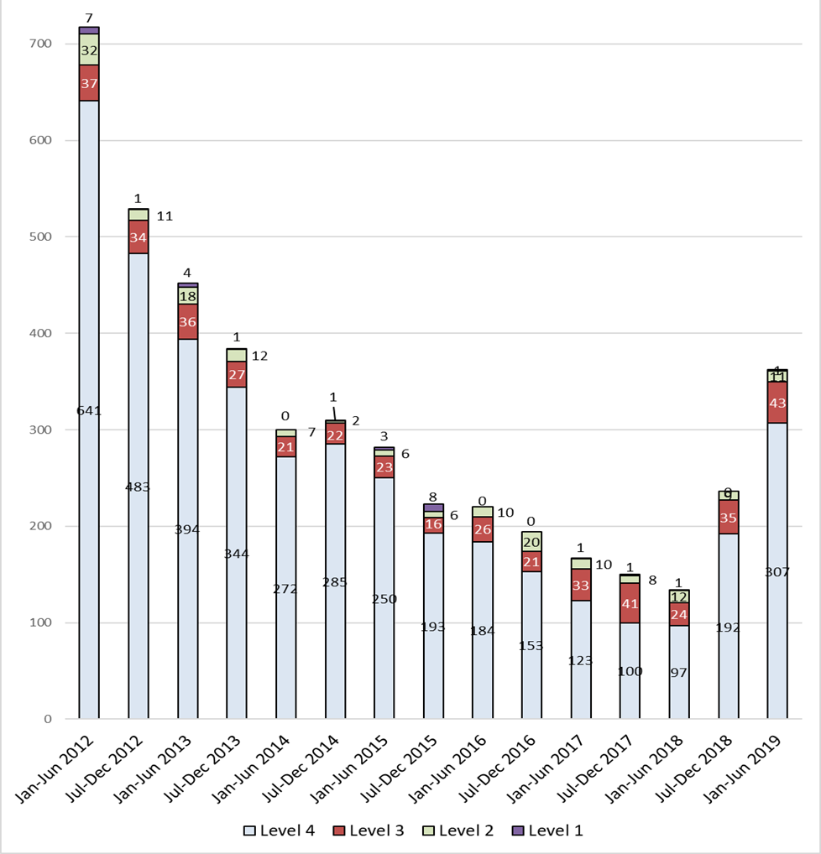

**TABLE C**

**FORCE APPLICATIONS REVIEWED IN FORCE BOARDS**

**January 1 through June 30, 2019**

|  |  |  |
| --- | --- | --- |
| **Quantity** | **UOF  Subtype** | **UOF Subtype Description** |
| 9 | 9 | Strike to the Head (excluding impact weapon strikes) |
| 15 | 12 | Impact Weapon with Contact - Regardless of Injury |
| 1 | 13 | Any Use of Force Resulting in Injury (Other than a Level 1 Force Type) |
| 1 | 14 | Police Canine Bites Clothing, Skin or Injures a Person Beyond First Aid |
| 4 | 15 | Other (Investigated as a Level 2)  - 15 (Non-categorized UOF) - 15-18 (Electronic Control Weapon but Probes Missed) - 15-16 (Weaponless Defense Technique Other than Control Hold) - 15-11 (Electronic Control Weapon) |
| 15 | 11 | Electronic Control Weapon |
| 12 | 16 | Weaponless Defense Technique Other than Control Hold |
| 2 | 18 | Electronic Control Weapon but Probes Missed |
| 1 | 19 | Non-Striking Use of a Baton |
| 2 | 22 | Intentionally Pointing a Firearm at a Person |

**TABLE D**

**OPD EMPLOYEE DEMOGRAPHICS**

**OPD ALL – PROFESSIONAL AND SWORN STAFF**

|  |  |  |  |  |  |  |
| --- | --- | --- | --- | --- | --- | --- |
| **Race/Ethnicity** | **Female #** | **Female %** | **Male #** | **Male %** | **TOTAL** | **%** |
| Asian | 48 | 12.3% | 120 | 15.42% | 168 | 14.4% |
| Black or African American | 152 | 38.9% | 136 | 17.48% | 288 | 24.6% |
| Filipino | 2 | 0.5% | 28 | 3.60% | 30 | 2.6% |
| Hispanic or Latino | 86 | 22.0% | 202 | 25.96% | 288 | 24.6% |
| Native American | 3 | 0.8% | 2 | 0.26% | 5 | 0.4% |
| Undeclared/Other | 6 | 1.5% | 22 | 2.83% | 28 | 2.4% |
| White or Caucasian | 94 | 24.0% | 268 | 34.45% | 362 | 31.0% |
| TOTAL | 391 | 100% | 778 | 100% | 1169 | 100.0% |

**OPD SWORN STAFF**

|  |  |  |  |  |  |  |
| --- | --- | --- | --- | --- | --- | --- |
| **Race/Ethnicity** | **Female #** | **Female %** | **Male #** | **Male %** | **TOTAL** | **%** |
| Asian | 7 | 7.0% | 89 | 13.71% | 96 | 12.8% |
| Black or African American | 20 | 20.0% | 106 | 16.33% | 126 | 16.8% |
| Filipino | 1 | 1.0% | 25 | 3.85% | 26 | 3.5% |
| Hispanic or Latino | 31 | 31.0% | 172 | 26.50% | 203 | 27.1% |
| Native American | 1 | 1.0% | 2 | .31% | 3 | 0.4% |
| Undeclared/Other | 4 | 4.0% | 14 | 2.16% | 18 | 2.4% |
| White or Caucasian | 36 | 36.0% | 241 | 37.13% | 277 | 37.0% |

**OPD PROFESSIONAL STAFF**

|  |  |  |  |  |  |  |
| --- | --- | --- | --- | --- | --- | --- |
| **Race/Ethnicity** | **Female #** | **Female %** | **Male #** | **Male %** | **TOTAL** | **%** |
| Asian | 41 | 14.1% | 31 | 24.00% | 72 | 17.1% |
| Black or African American | 132 | 45.4% | 30 | 23.30% | 162 | 38.6% |
| Filipino | 1 | 0.3% | 3 | 2.30% | 4 | 1.0% |
| Hispanic or Latino | 55 | 18.9% | 30 | 23.30% | 85 | 20.2% |
| Native American | 2 | 0.7% | 0 | 0.00% | 2 | 0.5% |
| Undeclared/Other | 2 | 0.7% | 8 | 6.20% | 10 | 2.4% |
| White or Caucasian | 58 | 19.9% | 27 | 20.90% | 85 | 20.2% |

**TABLE E**

**NON-COMPLIANT NSA TASKS**

|  |
| --- |
| **PARTIAL COMPLIANCE** |
| **Task 24** – OPD’s Office of Inspector General and the IMT identified underreporting of Level 4 Uses of Force. Upon discovery of reporting policy issues, OPD immediately changed training and policy to properly document force. New Use of Force Reporting Policy is slated to be published following the Oakland Police Commission approval. In 2019, OPD has seen a corrective spike in Use of Force Reporting. |
| **Task 25** – In both OIG and IMT audit reports of Use of Force reporting, no incident was found to be an excessive use of force. Several reporting recommendations made by OPD OIG audit has already been implemented. |
| **Task 34** - All stop data elements are captured in conjunction with this task and the new DOJ mandates. The department is 100% trained in Procedural Justice I and II and will begin part III in early Spring 2020 with community member instructors. Risk Management Dashboards will be released in early 2020 providing a tool for supervisors to measure stop data and other risk factors. |
| **Task 45** – Since December 2014, OPD has been partial compliance with Consistency of Discipline. OPD has implemented Court Appointed Investigator’s recommendations on improving OPD Disciplinary Processes. Since January 2015, the IMT has reviewed 365 disciplinary cases, 45 Skelly hearings and 4 arbitration findings. The IMT found no cases out of compliance related to Consistency of Discipline. |
| **OUT OF COMPLIANCE** |
| **Task 2** – In the 62nd IMT report, Task 2 was deemed out of compliance for the number of IAD cases not completed within 180 days. In July 2019, additional staffing was added to IAD and the backlog of IAD cases has been resolved. OPD expects to be back in compliance in early 2020 with Task 2, completing 90-100% IAD cases within 180 days. |
| **Task 5** – On March 23, 2016, the Court placed Task 5 out of compliance for IAD Case 15-0771 (sex scandal involving a juvenile.) In June 2017, Court Investigator Swanson’s report recommended nine (9) OPD internal improvements following the investigative completion of 15-0771. In September 2018, all nine recommendations were completed and reported to the court. Since April 2010, OPD has held a 90% IAD Case compliance rate (797cases of 876 cases audited by the IMT). OPD aims to continue its IAD case compliance and evolve from the mistakes noted by the Swanson report. |
| **Task 30** – After OPD created the Force Investigation Team in April 2013, OPD has held 23 Executive Force Review Boards with only one case (Pawlik shooting) deemed out of compliance by the IMT. OPD is focused on IAD and CID processes to attain compliance with the next EFRB. |

1. A single complaint may contain multiple allegations of misconduct.
2. A recent OIG audit of Level 4 UOF reporting found potential underreporting of the pointing of a firearm. The Chief directed refresher training on the reporting use of force in September 2018, and the number of Level 4 reported uses of force has increased significantly since then.    
3. By way of comparison, from January 1 to January 30 in the State of California 44 people were shot and killed by Police.