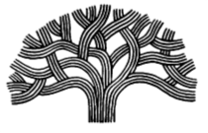

CITY OF OAKLAND
Youth Advisory Commission Meeting Agenda
October 10, 2019
150 Frank Ogawa Plaza, 4th Floor, Conference Room 1
Meeting: 5:00 P.M. – 7:00 P.M.

AGENDA

5:00-5:30pm Welcome
Team Building Activity
Food and Refreshments

5:30-7:00pm Training from Youth Leadership Institute
Training addresses “Training Objective #1” – Theories of Youth Development and Leadership Assessment.

7:00pm Meeting Adjourned

